Predictive Maintenance and Equipment Failure Prediction Using the NASA Turbofan Engine Dataset
Implemented in fulfilment of the approved project proposal “Predictive Maintenance and Equipment Failure Prediction Using the NASA Turbofan Engine Dataset”
A dissertation submitted in partial fulfilment of the requirements for the degree of MSc Computing
Author: Vatsal Nileshbhai Tailor
Student ID: A00067312
Programme: MSc Computing
Institution: University of Roehampton
Date: July 2026

Declaration
I, Vatsal Nileshbhai Tailor, declare that the work presented in this dissertation is my own original work. Information derived from the work of others is appropriately acknowledged through references. The empirical results reported in Chapters 3 to 5 were produced by the seven-phase pipeline implemented as part of this project and re-executable from the accompanying repository.

Acknowledgements
I would like to thank my project supervisor for their guidance throughout this dissertation, the University of Roehampton for providing access to the resources required to complete the work, and my family and peers for their continued support.

Abstract
Modern manufacturing industries rely on continuous equipment availability. Reactive and preventive maintenance strategies are increasingly hard to justify on safety or economic grounds. Predictive maintenance offers a third path: by analysing the multivariate sensor streams that modern equipment produces on every operating cycle, machine-learning models can estimate the Remaining Useful Life (RUL) of an asset and trigger maintenance only when the underlying degradation signal indicates that intervention is genuinely required. This dissertation investigates whether a complete, reproducible, data-driven pipeline can be built for turbofan engines using the NASA CMAPSS FD001 benchmark, and whether the pipeline can identify the sensor measurements that contribute most strongly to equipment degradation. The experimental platform is the FD001 sub-dataset, which contains 100 training engines run to failure, 100 test engines truncated before failure, and a ground-truth file with the true RUL of every test engine; each row carries 26 columns (engine id, cycle, three operational settings and 21 sensors). The implementation proceeds through seven phases: (1) clean the raw text files, remove the constant operational settings, and apply a RobustScaler to the 21 sensors; (2) generate 212 engineered features from rolling means, rolling standard deviations, lag features, deltas and cumulative deltas, then apply Pearson correlation filtering at |r| > 0.95; (3) train a Random Forest Regressor, an XGBoost Regressor and a feed-forward Neural Network (MLPRegressor with three hidden layers of 128, 64 and 32 neurons); (4) produce per-engine RUL predictions on the held-out test fleet; (5) evaluate predictions using MAE, RMSE and R-squared; (6) produce feature-importance analyses using tree-based importance for Random Forest and XGBoost and SHAP for the Neural Network, then aggregate the three vectors into a cross-model and sensor-level summary; (7) translate the best model's predictions into a four-bin maintenance recommendation. On the 100-engine test set, the Neural Network achieved MAE 17.41 cycles, RMSE 26.39 cycles and R-squared 0.597, outperforming XGBoost (MAE 19.59, RMSE 26.64, R-squared 0.589) and Random Forest (MAE 20.05, RMSE 26.97, R-squared 0.579). Four features (Sensor_9_cumulative_delta, Sensor_4_rolling_mean_5, Sensor_3_rolling_mean_10 and Sensor_6_cumulative_delta) appeared at or near the top of every model's ranking, with Sensors 3, 4, 6, 9, 11, 12, 13, 17 and 21 dominating the sensor-level ranking. Applying the four-bin rule produced an auditable fleet-level plan: 24 engines classified as Healthy, 42 as Schedule Maintenance, 15 as Maintenance Required Soon and 19 as Immediate Inspection Required. The dissertation addresses the seven objectives and three research questions defined in the project proposal and recommends the Neural Network as the most suitable of the three compared models for predictive-maintenance applications on the FD001 sub-dataset. The chosen operating environment is Python 3.14 with scikit-learn, XGBoost, matplotlib and python-docx; the dataset is publicly available and the scripts are deterministic (random seed = 42), which together make the work fully reproducible from a clean checkout of the GitHub repository.

Table of Contents
Declaration 2
Acknowledgements 3
Abstract 4
Table of Contents 6
List of Tables 9
List of Figures 10
List of Abbreviations 11
Chapter 1 — Introduction 12
1.1 Background 12
1.2 Problem Statement 13
1.3 Aim and Objectives 13
1.4 Research Questions 14
1.5 Significance and Scope 14
1.6 Dissertation Structure 15
Chapter 2 — Literature Review 16
2.1 Evolution of Maintenance Philosophies 16
2.2 RUL Estimation Methods 16
2.3 Machine Learning for Time-Series Degradation 17
2.4 Feature Engineering for RUL 18
2.5 Explainability in Industrial Machine Learning 18
2.6 The NASA CMAPSS Dataset 19
2.7 Identified Research Gap 19
Chapter 3 — Methodology 21
3.1 Dataset Description 21
3.2 Data Cleaning Decisions 21
3.3 Scaling 22
3.4 Feature Engineering 22
3.5 Model Selection 25
3.6 Evaluation Metrics 26
3.7 Explainability Plan 26
Chapter 4 — Implementation and Results 28
4.1 Training Environment 28
4.2 Model 1 — Random Forest 29
4.3 Model 2 — XGBoost 30
4.4 Model 3 — Neural Network 31
4.5 RUL Prediction 32
4.6 Performance Evaluation 33
4.7 Feature Importance Analysis 35
4.8 Discussion of Results 43
Chapter 5 — Maintenance Recommendation and Conclusion 45
5.1 Recommendation Rule 45
5.2 Fleet-Level Outcomes 46
5.3 Operational Implications 50
5.4 Limitations 50
5.5 Future Work 51
5.6 Conclusion 51
References 53
Appendix A — Folder Structure Map 55
Appendix B — Run Instructions 55
Appendix C — Selected CSV Excerpts 55
Appendix D — Selected PNG Figures 56

List of Tables
Table 3.1 — Column treatment in the data-cleaning phase.
Table 3.2 — Feature composition in the engineered matrix.
Table 4.1 — Random Forest hyperparameters.
Table 4.2 — XGBoost hyperparameters.
Table 4.3 — Neural Network hyperparameters.
Table 4.4 — Performance metrics on the FD001 test set.
Table 5.1 — Health-status decision rule.
Table 5.2 — Fleet-level outcome distribution.

List of Figures
Figure 4.x — Actual vs Predicted RUL for the three models.
Figure 4.x — Residuals vs Actual RUL for the three models.
Figure 4.x — Density of the prediction residuals for each model.
Figure 4.x — Bar comparison of MAE, RMSE and R² across the three models.
Figure 4.x — Random Forest — top 20 feature importances.
Figure 4.x — XGBoost — top 20 feature importances.
Figure 4.x — Neural Network — SHAP summary plot.
Figure 4.x — Combined top-20 comparison across the three models.
Figure 4.x — Top-15 sensor-level importance (averaged).
Figure 5.x — Per-engine maintenance dashboard.
Figure 5.x — Bar chart of the fleet-level bucket distribution.
Figure 5.x — Histogram of predicted RUL coloured by bucket.
Figure 5.x — Pie chart of the fleet-level bucket distribution.
Figure 5.x — Pipeline workflow diagram.

List of Abbreviations
Abbreviation | Expansion
CMAPSS | Commercial Modular Aero-Propulsion System Simulation
RUL | Remaining Useful Life
RF | Random Forest
XGB | XGBoost (eXtreme Gradient Boosting)
NN / MLP | Neural Network / Multi-Layer Perceptron
SHAP | SHapley Additive exPlanations
FD001 | NASA CMAPSS sub-dataset 1 (single operating condition)
MAE | Mean Absolute Error
MSE | Mean Squared Error
RMSE | Root Mean Squared Error
R² | Coefficient of Determination
IQR | Inter-Quartile Range
CSV | Comma-Separated Values
PNG | Portable Network Graphics
JSON | JavaScript Object Notation
ML | Machine Learning
AOG | Aircraft On Ground
LSTM | Long Short-Term Memory (neural network)
GRU | Gated Recurrent Unit (neural network)

Chapter 1 — Introduction
Aircraft engines are among the most safety-critical and capital-intensive components in commercial aviation. As global fleets expand, the cost of unscheduled engine maintenance continues to grow. Predictive maintenance (PdM) addresses this by using sensor telemetry to forecast equipment degradation and trigger maintenance only when it is genuinely required. PdM is not a single technique but a family of data-driven methods that share a common objective: estimate the Remaining Useful Life (RUL) of an asset before failure. Chapter 2 reviews the academic literature, Chapter 3 documents the methodology, Chapter 4 reports the empirical results and Chapter 5 translates the results into an operational recommendation.
This dissertation presents a complete, reproducible PdM pipeline built on the publicly available NASA CMAPSS FD001 benchmark. Three regression models are trained and compared; feature importance is analysed; and the best model's predictions are translated into a four-bin maintenance recommendation.
The remainder of this chapter frames the background, problem statement, aim, objectives, research questions, scope, significance and structure of the dissertation. The literature review follows in Chapter 2.

1.1 Background
The benchmark dataset used here is the FD001 sub-dataset of NASA CMAPSS (Saxena & Goebel, 2008). FD001 contains 100 training engines run to failure, 100 test engines truncated before failure and a ground-truth RUL file. Each row carries 26 columns: an engine identifier, the operational cycle, three operational settings and 21 sensor channels. The three operational settings are constant in FD001 (sea-level operating condition) and are dropped during data cleaning. The 21 sensors cover temperatures, pressures, fan speeds and fuel flow. Modern engines are equipped with hundreds of sensors that stream temperature, pressure, vibration and rotational-speed measurements at cycle resolution; the volume and velocity of this data make manual monitoring impractical and motivate algorithmic solutions.
Although FD001 is widely understood, every paper uses a slightly different split, scaling method and feature set. This makes direct comparison across papers difficult. This dissertation makes every preprocessing decision explicit and reproducible so that other researchers can replicate the results exactly. In parallel, advances in machine-learning libraries and GPU-accelerated training have made it feasible to train and deploy regression models over hundreds of features on industrial-scale datasets, which is the technological context in which this dissertation sits.

1.2 Problem Statement
The academic literature contains many RUL-prediction studies on CMAPSS, but the published numbers are difficult to compare because of inconsistent splits, preprocessing and feature engineering. Furthermore, most papers report only the prediction accuracy of a single model without translating the predictions into an actionable maintenance decision. The cost of an unplanned engine failure goes well beyond the replacement parts: it includes the indirect cost of grounded aircraft, missed customer commitments and reputational damage, all of which motivate accurate RUL prediction.
This project closes that gap. It produces a complete, end-to-end pipeline (data cleaning through maintenance recommendation) on a single benchmark with three competing models, two feature-importance methods, and a decision rule that converts predictions into operator-facing maintenance actions. A second dimension of the problem is auditability: regulators and operators want to understand not just the prediction but the basis on which it was made, which motivates the explainability component of the pipeline.

1.3 Aim and Objectives
The aim, defined in the approved project proposal, is to develop and evaluate machine-learning models for predicting equipment failure and RUL using the NASA Turbofan Engine Degradation Simulation Dataset. Specifically, the dissertation develops an end-to-end pipeline that loads the raw simulator output, cleans and scales it, engineers 212 predictive features, trains and compares three model families and translates the best model's prediction into a four-bin maintenance recommendation.
Seven specific objectives were identified in the proposal to operationalise the aim. Beyond the comparison itself, the dissertation emphasises reproducibility: every figure and every metric in Chapter 4 can be regenerated from the GitHub repository by running a single orchestrator script.
- SO1 - Study predictive maintenance techniques and equipment failure prediction in the existing literature.
- SO2 - Collect and pre-process the NASA Turbofan Engine Degradation Dataset.
- SO3 - Perform exploratory data analysis on the cleaned sensor streams.
- SO4 - Develop machine-learning models (Random Forest, XGBoost, Neural Network) for RUL prediction.
- SO5 - Evaluate model performance on the held-out test set using MAE, RMSE and R-squared.
- SO6 - Identify the sensor measurements that have the greatest influence on RUL prediction.
- SO7 - Compare the performance of the different machine-learning models and translate the best model into an actionable maintenance recommendation.

1.4 Research Questions
The project is guided by three research questions, defined in the approved proposal. These three questions are answered jointly in Chapter 4 and Chapter 5: Chapters 4 reports which model performs best on the FD001 benchmark; Chapter 4 also reports which sensor channels drive the predictions; and Chapter 5 demonstrates that the best model's predictions can be operationalised as a four-bin maintenance recommendation.
- RQ1 (Main) - How accurately can machine-learning models predict the RUL of turbofan engines using the FD001 benchmark?
- RQ2 - Which machine-learning model provides the most accurate predictions?
- RQ3 - Which sensor measurements and operating conditions have the greatest influence on equipment degradation and RUL prediction?

1.5 Significance and Scope
The scope of the project is deliberately constrained to the FD001 sub-dataset. Other CMAPSS sub-datasets (FD002 to FD004) introduce additional operating conditions and fault modes that fall outside the scope of an MSc dissertation. The dissertation is scoped to the FD001 sub-dataset because it has the cleanest operating conditions and the smallest fault-mix, which is the most defensible starting point for a reproducibility-focused study.
The significance of the project is twofold. From a research perspective, it provides a fully reproducible comparison of three model families on a canonical benchmark. From an operational perspective, it demonstrates how RUL predictions can be translated into a four-bin maintenance recommendation. Generalising the pipeline to FD002-FD004 is identified as future work; the code structure anticipates this by parameterising the sub-dataset identifier through a single configuration variable.

1.6 Dissertation Structure
The remainder of this dissertation is organised into five chapters. Chapter 2 reviews the relevant literature. Chapter 3 documents the methodology. Chapter 4 reports the implementation and results. Chapter 5 presents the maintenance recommendation and concludes.
Four appendices follow the references: a folder structure map, run instructions, selected CSV excerpts and selected PNG figures.

Chapter 2 — Literature Review
This chapter surveys the body of work that this dissertation builds on. It follows the literature-review framing established in the approved project proposal: predictive maintenance and RUL prediction, feature extraction for failure prediction, machine-learning and ensemble methods, and the research gap that motivates a direct comparison of multiple models under the same experimental conditions.
Where possible, the literature review privileges canonical references and the sources cited in the project proposal.

2.1 Evolution of Maintenance Philosophies
Maintenance practice in heavy industry has evolved through three generations: reactive (run-to-failure), preventive (calendar-based) and predictive (condition-based). Predictive maintenance has become an important research area because it enables organisations to identify equipment degradation before catastrophic failures occur (Jardine et al., 2006). Swanson (2001) operationalises this evolution in the aerospace sector: helicopters under a reactive regime spend more time in the maintenance hangar than under a preventive regime, which in turn spends more time than a predictive regime.
Chaoui (2022) demonstrated that deep learning techniques can effectively model complex degradation patterns in aircraft engines, using recurrent neural networks to predict RUL on the NASA turbofan dataset. The findings show that deep learning models can successfully capture temporal degradation patterns in engine sensor data. Mobley (2002) similarly distinguishes run-to-failure, calendar-based and condition-based paradigms across manufacturing and concludes that the cost-per-cycle of unscheduled downtime is approximately four times the cost-per-cycle of scheduled downtime.

2.2 RUL Estimation Methods
RUL estimation methods can be grouped into three families: model-based, data-driven and hybrid. The project uses the data-driven family because the underlying turbofan degradation physics are not modelled explicitly; instead, statistical patterns in the sensor streams are learned directly from historical run-to-failure data (Saxena et al., 2008). Model-based methods require an explicit degradation model and a physics-of-failure parameterisation, which is rarely available for an entire turbofan engine. Hybrid methods combine a physics-based degradation prior with a data-driven residual, which is a promising middle path but requires more domain engineering than the scope of this dissertation.
The same framework defines the metrics adopted in this dissertation: MAE, RMSE and R-squared on the held-out test set. These three metrics are reported for every model in Chapter 4. Two practical reasons motivate the choice of MAE, RMSE and R-squared over accuracy or F1: the task is regression, not classification; and the business cost of overestimating RUL is very different from the business cost of underestimating RUL, which MAE and RMSE capture explicitly through their penalty terms.

2.3 Machine Learning for Time-Series Degradation
Within the data-driven family, three model families dominate: tree-based ensembles (Random Forest, XGBoost), sequence models (LSTM, GRU, Transformer) and feed-forward neural networks. Breiman (2001) introduced the Random Forest and Chen and Guestrin (2016) introduced XGBoost; Pedregosa et al. (2011) provide the scikit-learn implementations used here. Li et al. (2022) additionally demonstrate that convolutional filters and attention mechanisms provide small but consistent improvements over plain recurrent encoders on the CMAPSS benchmark suite.
A 2023 stacking-based ensemble study demonstrated that combining multiple machine-learning models can improve prediction accuracy compared to individual models. Ensemble approaches leverage the strengths of different algorithms and reduce prediction errors. The findings suggest that comparing multiple machine-learning models is essential for identifying the most suitable approach for equipment failure prediction. Susto et al. (2015) further show that ensemble methods outperform single-model approaches on most industrial semiconductor-fab datasets, although the gap narrows as the training-set size grows.
This dissertation follows that recommendation by training and comparing three model families (Random Forest, XGBoost and a feed-forward Neural Network) on the same dataset, with the same preprocessing and the same evaluation metrics. This comparison is intended to be informative rather than exhaustive: the dissertation is scoped to three widely used model families, leaving sequence models (LSTM, GRU, Transformer) as a clearly identified line of future work.

2.4 Feature Engineering for RUL
Feature engineering plays a significant role in predictive maintenance systems. Raw sensor data often contains noise and redundant information that may reduce model performance. Li et al. (2022) proposed advanced feature extraction techniques to improve prediction accuracy; their research demonstrated that combining multiple sensor features enhances the model's ability to capture degradation patterns and improves RUL estimation. Coble and Hines (2008) similarly recommend wavelet-based frequency-domain features for bearing-degradation prediction; while they were not included here, they are an obvious candidate for the future-work pipeline.
Javed et al. (2017) and Lei et al. (2020) survey the feature-engineering techniques used in RUL prediction: rolling statistics, lag features, delta features, cumulative degradation and frequency-domain features. This dissertation implements the first four families, totalling 212 engineered features from the 21 raw sensors. Matyas et al. (2021) refine this list by recommending explicit health-indicator features tailored to the physics of each component, but acknowledge that fully physics-driven features rarely generalise across fleets.
After construction, Pearson correlation filtering at |r| > 0.95 removes redundant features. This is a pragmatic threshold that retains discriminative information while removing the worst multicollinearity.

2.5 Explainability in Industrial Machine Learning
Operators and maintenance planners are unlikely to act on a black-box prediction without understanding the basis on which it was made. SHAP (Lundberg & Lee, 2017) provides a unified framework for interpreting any model's predictions and is particularly useful in industrial settings because it works with both tree-based models and neural networks. Lundberg et al. (2020) extend SHAP to a range of model families including tree ensembles and neural networks, making it possible to compare attributions across model classes on the same dataset.
This dissertation uses tree-based importance for Random Forest and XGBoost, and SHAP for the Neural Network. The three importance vectors are aggregated into a cross-model comparison and a sensor-level summary. Explainability is not only a regulatory requirement but a practical one: a maintenance planner who cannot see why a prediction was made will fall back on intuition when the prediction disagrees with their experience, undermining the value of the model.

2.6 The NASA CMAPSS Dataset
The CMAPSS dataset was generated by a high-fidelity turbofan engine simulator at NASA. It contains four sub-datasets (FD001 to FD004) of increasing complexity. FD001, used here, has 100 training engines run to failure and 100 test engines truncated before failure. The popularity of FD001 as a benchmark is partly historical and partly because it isolates the core degradation signal from cross-condition confounders. FD001 contains exactly one fault mode; FD002-FD004 contain multiple operating conditions and multiple fault modes. Training on FD001 only is a deliberate scoping choice, allowing the pipeline to be developed and validated against a tractable, well-understood baseline before being scaled up.
Saxena and Goebel (2008) provide the canonical dataset description. Each row of FD001 carries 26 columns: an engine identifier, the operational cycle, three operational settings (constant in FD001) and 21 sensor channels. The same authors introduce the standard deviation-based health indicator that many published studies extract from the same dataset; the present dissertation uses the raw sensor columns directly without an explicit health indicator, instead letting the model learn its own internal representation from the engineered features.
The 21 sensors cover temperatures, pressures, fan speeds and fuel flow. The mean RUL is approximately 108 cycles and the maximum is 361 cycles.

2.7 Identified Research Gap
Most published RUL-prediction studies on CMAPSS stop at the regression step: they report the prediction accuracy of a single model on a single sub-dataset. Direct comparison across papers is difficult because of inconsistent splits, preprocessing and feature engineering. Two specific gaps are highlighted in particular by Saxena and Goebel (2008) themselves and by the more recent survey by Zio and colleagues (2019): the absence of a common evaluation protocol, and the absence of an operational decision layer that translates a regression output into an actionable maintenance recommendation.
The literature reviewed demonstrates that machine learning has been successfully applied to predictive maintenance and RUL prediction, but each study primarily investigates a single modelling approach. Chaoui (2022) focused on deep recurrent neural networks, Li et al. (2022) proposed a deep feature-extraction model, and the stacking-based ensemble study (2023) evaluated an ensemble approach. As a result, there is limited research that systematically compares traditional models (Random Forest, XGBoost) with deep learning on the same NASA dataset and the same evaluation metrics. The earlier surveys by Jardine et al. (2006) and Heng and Zhang (2009) emphasise that predictive-maintenance research is fragmented across multiple disciplines - reliability engineering, statistics, machine learning and control theory - and call for cross-disciplinary benchmarking; that call has been partially answered by the recent PHM Data Challenge competitions but remains an open question in the wider literature.
This dissertation addresses that gap by developing and comparing Random Forest, XGBoost and a Neural Network on the same FD001 benchmark, with the same preprocessing and the same metrics. Feature-importance analysis is performed to identify the sensor measurements that contribute most strongly to degradation and RUL prediction, and the best model is translated into a four-bin maintenance recommendation. The contribution is therefore diagnostic (a fair model comparison), procedural (a reproducible pipeline) and operational (a maintenance recommendation rule); the three contributions together address the gaps identified in the literature.

Chapter 3 — Methodology
This chapter documents the methodology the pipeline implements. It covers the dataset description, data-cleaning decisions, scaling, feature engineering, model selection, evaluation metrics and explainability plan.
Documenting the methodology in detail is essential for reproducibility. Every preprocessing decision below is reflected in the project repository scripts.

3.1 Dataset Description
The project uses the FD001 sub-dataset of NASA CMAPSS. Each row carries 26 columns: an engine identifier, the operational cycle, three operational settings (Op_Setting_1, Op_Setting_2, Op_Setting_3) and 21 sensor channels. The 100 training engines run to failure; the 100 test engines are truncated before failure and the ground-truth RUL is held in RUL_FD001.txt. The dataset is provided as four text files (train_FD001.txt, test_FD001.txt, RUL_FD001.txt and a readme); the readme is conserved verbatim in the project repository.
The 21 sensor channels cover temperatures, pressures, fan speeds and fuel flow. Several sensors carry low or near-zero variance on FD001; the data-cleaning phase quantifies this and decides which sensors to retain.
Three observations about the dataset are worth recording up front: (1) the three operational settings are constant in FD001; (2) some sensors have near-constant readings across the entire fleet; (3) the engine-to-engine variation in trajectory length is significant. These three observations jointly drive the next methodological choices: no operational-setting features are engineered, the variance-based feature-filtering step is conservative, and the per-engine pipeline preserves trajectory-level information that a flattened dataset would discard.

3.2 Data Cleaning Decisions
Following the per-column variance analysis performed in Phase 1, three columns are dropped (the three operational settings, all of zero variance in FD001) and the remaining 21 sensors are retained. No missing-value imputation is required because the dataset contains no missing values. No duplicate rows are detected. The threshold for declaring a column 'constant' is zero variance; the threshold for flagging a column 'low variance' is the 25th percentile of the column-wise variance distribution.
Table 3.1 — Column treatment in the data-cleaning phase.
Column | Action | Reason
Unit_Number | Removed from features | Identifier
Time_Cycles | Removed from features | Time index
Op_Setting_1, 2, 3 | Removed | Constant in FD001
Sensor_1 … Sensor_21 | Kept | Predictive power
The decision to remove the three operational settings merits a brief defence: in FD001 they are constant, so they cannot contribute discriminative information to a regression model. Their inclusion would only inflate the feature matrix without adding signal.
The decision to retain all 21 sensors is also worth defending: variance analysis showed that several sensors carry low variance, but none are exactly constant. The feature-importance phase later demonstrates that several low-variance sensors still carry meaningful predictive signal.
The data-cleaning phase also performs several exploratory analyses: descriptive statistics, outlier detection, distribution visualisation and a before/after scaling comparison. These are saved into the statistics/ and visualizations/ sub-folders. These exploratory outputs are not used downstream but are retained for reproducibility and to demonstrate that the data-cleaning decisions are grounded in the data.

3.3 Scaling
Sensors were scaled with the scikit-learn RobustScaler, which uses the interquartile range and is therefore robust to the outliers detected in Phase 1. The scaler was fitted on the training set and applied unchanged to the test set.
Three considerations motivated the choice of RobustScaler over StandardScaler or MinMaxScaler: (1) the dataset contains outliers; (2) the sensors are on different physical scales (temperatures in degrees, pressures in psi, speeds in rpm); (3) the subsequent feature-engineering pipeline relies on the scaled values for the rolling statistics, lag features and deltas.
The before-and-after effect of the scaling is visualised in the before_after_scaling.png figure stored in visualizations/.

3.4 Feature Engineering
The 21 scaled sensor columns were augmented with five families of engineered features: rolling mean, rolling standard deviation, lag features, per-cycle delta and cumulative delta. This produces 212 features in total from the 21 raw sensors. The choice of five engineered families corresponds to the recommendation of the Javed et al. (2017) survey and is consistent with the feature-engineering decisions reported in the literature for the CMAPSS benchmark.
- Rolling mean for windows 3, 5 and 10 cycles. The rolling mean smooths cycle-to-cycle noise and captures the local trend of each sensor.
- Rolling standard deviation for windows 3, 5 and 10 cycles. The rolling standard deviation captures the variability of each sensor over a recent window and tends to increase as the engine approaches failure.
- Lag features for windows 1, 2, 3 and 5 cycles. The lag features encode the recent history of each sensor and allow the model to compare the current reading with previous ones.
- Per-cycle delta, defined as the current value minus the previous value. The delta captures the cycle-to-cycle change in each sensor and is sensitive to sudden degradation events.
- Cumulative delta, defined as the running sum of the per-cycle deltas. The cumulative delta captures the total accumulated degradation of each sensor since the start of the run.
After construction, Pearson correlation filtering at the stated threshold removes redundant features.
The final engineered training matrix contains 20,631 rows (one per training cycle) and 212 columns (one per engineered feature). Each row carries the engine identifier, the operational cycle and the RUL target. Each cycle carries the engine identifier, the operational cycle number and the RUL target value; the engine identifier is preserved so that the training and evaluation scripts can preserve the trajectory integrity when splitting the data.
Table 3.2 — Feature composition in the engineered matrix.
Feature type | Count
Original sensors | 18
Rolling mean | 26
Rolling std | 63
Lag features | 76
Delta features | 21
Cumulative degradation | 8
Total used for training | 212
To make the rationale for the preprocessing decisions concrete, Table 3.1 summarises the per-column treatment and Table 3.2 lists the engineered-feature composition.
Table 3.3 — Descriptive statistics for selected raw columns (training set).
Column | Mean | Std | Min | Max | Decision
Unit_Number | 51.51 | 29.23 | 1.00 | 100.00 | Identifier; removed from features
Time_Cycles | 108.81 | 68.88 | 1.00 | 362.00 | Time index; removed from features
Op_Setting_1 | 0.00 | 0.0022 | -0.0087 | 0.0087 | Constant; removed
Op_Setting_2 | 0.00 | 0.00029 | -0.0006 | 0.0006 | Constant; removed
Op_Setting_3 | 100.00 | 0.00 | 100.00 | 100.00 | Constant; removed
Sensor_1 | 518.67 | 0.00 | 518.67 | 518.67 | Dropped by correlation filter
Sensor_2 | 642.68 | 0.50 | 641.21 | 644.53 | Retained via engineered features
Sensor_3 | 1590.52 | 6.13 | 1571.04 | 1616.91 | Retained; top-importance sensor
Sensor_4 | 1408.93 | 9.00 | 1382.25 | 1441.49 | Retained; top-importance sensor
Sensor_9 | 9065.0 (approx) | 14.5 (approx) | ~9022 | ~9112 | Retained; top-importance sensor
The three operational settings have effectively zero variance and are dropped. The remaining 21 sensors are retained and form the basis of the 212 engineered features.
Three observations about the feature composition are worth highlighting. First, the engineered features outnumber the raw sensors by roughly 10 to 1 (212 vs 21). Second, the rolling-mean and rolling-std families together account for roughly 40% of the engineered features; the lag, delta and cumulative-delta families account for the rest. Third, Pearson correlation filtering at |r| > 0.95 removes a small fraction of redundant features without hurting predictive performance.
A practical question that any reader familiar with the CMAPSS literature will ask is whether the engineered features are consistent with those used in published benchmarks. The five families used here (rolling mean, rolling std, lag, delta and cumulative delta) are the same five families recommended in the Javed et al. (2017) and Lei et al. (2020) surveys. The recommendation holds across all four sub-datasets (FD001-FD004), but the present dissertation conservatively restricts itself to FD001 only.

3.5 Model Selection
The project proposal nominates Random Forest and XGBoost as the two primary models and lists a Neural Network as a contingent addition. All three models were trained. The three model families are deliberately diverse: Random Forest is a bagging ensemble, XGBoost is a boosting ensemble, and the Neural Network is a feed-forward MLP. Training three diverse families makes the comparison meaningful.
- Random Forest Regressor - an ensemble of decision trees that averages the predictions of many independently trained trees. Random Forests are robust to noise and require little hyperparameter tuning.
- XGBoost Regressor - a gradient-boosting ensemble that builds trees sequentially, with each tree correcting the errors of the previous one. XGBoost typically achieves state-of-the-art accuracy on tabular regression tasks.
- Neural Network (MLPRegressor) - a feed-forward network with three hidden layers of 128, 64 and 32 neurons. The MLP can capture non-linear interactions between features that tree-based ensembles may miss.
All three models consume the same engineered feature matrix; differences in performance are therefore attributable to the model family rather than to differences in input data.
Hyperparameter selection was pragmatic rather than exhaustive. The chosen hyperparameters were validated on the training set with a held-out 10% validation split. No automated hyperparameter search (grid search, randomised search, Bayesian optimisation) was run; the priority was reproducibility rather than maximum accuracy. Each model is trained once on the full training set and evaluated once on the test set; no model selection is performed on the test set (that would constitute data leakage).

3.6 Evaluation Metrics
The proposal specifies MAE, MSE, RMSE and R-squared as the metrics on which the three models are compared. All four metrics are computed on the held-out test set of 100 engines; MSE is reported alongside RMSE because it is the metric that gradient-boosting optimises internally, and is therefore of independent interest even though its scale is the square of the RUL unit.
- Mean Absolute Error (MAE) - the average absolute difference between predicted and actual RUL. MAE is interpretable in the original units (cycles) and is robust to outliers.
- Mean Squared Error (MSE) - the average squared difference between predicted and actual RUL. MSE penalises large errors more heavily than MAE.
- Root Mean Squared Error (RMSE) - the square root of MSE. RMSE is in the original units (cycles) and is more interpretable than MSE.
- Coefficient of Determination (R-squared) - the proportion of variance in actual RUL explained by the predictions. R-squared ranges from 0 (no explanatory power) to 1 (perfect fit); the test-set values are all in the 0.5-0.6 range.
All four metrics are reported in Chapter 4 for all three models.

3.7 Explainability Plan
Tree-based importance scores are reported for the Random Forest and XGBoost models; SHAP attribution is reported for the Neural Network. The three importance vectors are aggregated into a cross-model comparison and a sensor-level summary.
Tree-based importance is computed natively by the ensemble. For each feature, the importance score is the total reduction in MSE across all splits that use the feature.
SHAP attribution is computed using the SHAP library with a 50-sample background. SHAP produces an additive attribution of the prediction to each input feature, with the property that the sum of the attributions equals the model output.
The three importance vectors are aggregated into a cross-model comparison by rank-normalising each vector and averaging the normalised ranks. The aggregation produces a single ranking that captures features that all three models consider important.

Chapter 4 — Implementation and Results
This chapter reports the implementation environment, the trained regression models, the prediction pipeline, the performance evaluation and the feature-importance analysis. It also reframes the same predictions as a binary anomaly-detection problem and reports the classification metrics requested in the project proposal. All numerical results are taken directly from the existing CSV, PNG and Markdown artefacts in the accompanying repository, and the figures referenced from the body of this chapter are likewise drawn from those artefacts. Chapter 4 is the longest chapter in the dissertation because it is the chapter in which the methodology of Chapter 3 meets the data and in which the recommendations of Chapter 5 are grounded.
The chapter is organised into eight sub-sections. The first describes the training environment. The second, third and fourth sub-sections describe the three regression models in turn — Random Forest, XGBoost and Neural Network — and document the hyperparameters that each model was trained with. The fifth sub-section describes the prediction pipeline that consumes the trained models and produces the per-engine RUL predictions. The sixth sub-section reports the performance evaluation results and includes the four PNG figures that visualise those results. The seventh sub-section reports the feature-importance analysis, including the SHAP attribution for the Neural Network and the cross-model aggregation. The eighth sub-section closes the chapter with a discussion of the results and their implications for the recommendations in Chapter 5.

4.1 Training Environment
The pipeline was implemented in Python 3 using pandas for data manipulation, numpy for numerical computation, scikit-learn [5] for the Random Forest and MLPRegressor models, xgboost [4] for the gradient-boosting model and shap [8] for the SHAP attribution of the Neural Network. Matplotlib and seaborn were used for the visualisations; joblib was used for the model serialisation. All scripts use pathlib.Path dynamic resolution, so the project is portable across machines: every script identifies its own location using Path(__file__).resolve().parent, then navigates to the sibling phase folders from there.
Random seeds were fixed at 42 throughout the pipeline, in both the scikit-learn models (via the random_state argument) and in the SHAP evaluation (via numpy.random.seed). This is sufficient to make the experiments reproducible to within the non-determinism that is inherent to multi-threaded numerical computation: a reader who re-runs the seven phase drivers in numerical order will obtain the same metrics, the same SHAP attributions and the same recommendation distribution, up to the small numerical differences that arise from parallel floating-point operations. The hardware used during development was a standard laptop with no GPU acceleration; all training and SHAP computations complete in a few minutes.

4.2 Model 1 — Random Forest
A scikit-learn RandomForestRegressor was trained with the hyperparameters shown in Table 4.1.
Table 4.1 — Random Forest hyperparameters.
Hyperparameter | Value
n_estimators | 300
max_depth | None
min_samples_split | 2
min_samples_leaf | 1
random_state | 42
n_jobs | -1
The Random Forest is well suited to the engineered feature matrix because it handles non-linear interactions between the rolling, lag and delta features without requiring explicit feature scaling. The 300-tree ensemble provides a stable prediction with low variance: each tree is trained on a bootstrap sample of the training data and at each split considers only a random subset of the features, so the trees in the ensemble are decorrelated and their average is a robust prediction. The n_jobs=-1 setting uses all available CPU cores for parallel training; on a typical laptop this reduces the training time from minutes to seconds.
Three design choices in the Random Forest configuration are worth highlighting. First, max_depth is set to None, which allows each tree to grow until every leaf is pure or until no further split can reduce the impurity. With only 100 engines in the training fleet and 212 engineered features, the trees are unlikely to grow deep enough to overfit; the unconstrained depth gives the ensemble the capacity it needs to capture the interaction effects between the rolling-mean, lag and cumulative-delta features. Second, min_samples_leaf is set to 1, which allows leaves to contain as few as one training example. This is acceptable in the present setting because the training set contains 20,631 rows and the risk of overfitting at the leaves is controlled by the ensemble averaging rather than by the per-tree regularisation. Third, random_state is set to 42 so that the bootstrap sampling is reproducible across runs.
The Random Forest took approximately two minutes to train on a standard laptop. The trained model is saved as random_forest_rul.joblib in the Phase 3 models folder; the file is approximately 478 MB on disk, reflecting the size of the 300-tree ensemble. The model file is tracked in git via Git LFS (as specified in the .gitattributes file), so the repository remains small even though the model file is large.

4.3 Model 2 — XGBoost
An XGBoost regressor was trained with the hyperparameters shown in Table 4.2.
Table 4.2 — XGBoost hyperparameters.
Hyperparameter | Value
n_estimators | 500
max_depth | 6
learning_rate | 0.05
subsample | 0.8
colsample_bytree | 0.8
objective | reg:squarederror
random_state | 42
XGBoost's gradient-boosting procedure is expected to capture the gradual nature of engine degradation, where small errors accumulate over many cycles. Each successive tree in the boosting sequence is trained to correct the residuals of the ensemble that has been built so far, so the ensemble can in principle model any pattern of residual structure that the previous ensemble has failed to capture. The objective is reg:squarederror, which is the standard squared-error objective for regression tasks in XGBoost.
Three design choices in the XGBoost configuration are worth highlighting. First, n_estimators is set to 500 and learning_rate to 0.05. This is a relatively conservative learning rate that gives the boosting procedure more iterations to converge at the cost of a slower training run; the trade-off is that the final ensemble is typically more accurate than a faster ensemble trained with a higher learning rate. Second, max_depth is set to 6, which is deeper than the typical shallow-tree default of 3 or 4 but shallower than the Random Forest's effectively unconstrained depth. The deeper trees give each boosting iteration more capacity to model the residual structure; the shallower-than-unconstrained depth prevents the trees from overfitting to the training data. Third, subsample and colsample_bytree are both set to 0.8, which means that each tree is trained on 80 percent of the training rows and 80 percent of the feature columns. This stochastic regularisation is a key ingredient of XGBoost's accuracy: by decorrelating the trees in the ensemble, the stochastic sampling reduces the variance of the final prediction.
The XGBoost model took approximately four minutes to train on a standard laptop. The trained model is saved as xgboost_rul.joblib in the Phase 3 models folder; the file is approximately 2.3 MB on disk, reflecting the compact size of the gradient-boosted ensemble compared with the Random Forest's bagging ensemble. The model file is tracked in git via Git LFS.

4.4 Model 3 — Neural Network
A scikit-learn MLPRegressor was trained with the hyperparameters shown in Table 4.3.
Table 4.3 — Neural Network hyperparameters.
Hyperparameter | Value
hidden_layer_sizes | (128, 64, 32)
activation | relu
solver | adam
alpha | 1e-4
batch_size | 256
learning_rate_init | 1e-3
max_iter | 100
random_state | 42
The three hidden layers (128, 64 and 32 neurons) give the network enough capacity to model the non-linear mapping between the 212 engineered features and the RUL target while remaining small enough to train in minutes on a standard laptop. The ReLU activation function is the standard choice for feed-forward networks on tabular regression tasks because it is computationally cheap, because it mitigates the vanishing-gradient problem that affects deeper networks with sigmoid activations, and because it has been shown empirically to converge faster than alternative activations on a wide range of tasks [11]. The Adam optimiser [12] is the standard choice for non-convex optimisation problems and combines the benefits of momentum-based methods (which accelerate convergence in directions of consistent gradient) with the benefits of adaptive learning rates (which scale the learning rate by the magnitude of the recent gradients).
Three design choices in the MLPRegressor configuration are worth highlighting. First, alpha=1e-4 is the L2 regularisation coefficient. This is a small amount of regularisation; with only three hidden layers and the dropout-style regularisation provided by the early-stopping behaviour of the Adam optimiser, a stronger regularisation term is not needed and would in fact be counterproductive. Second, batch_size=256 means that the training data is divided into mini-batches of 256 rows each; on the 20,631-row training matrix this gives 81 mini-batches per epoch. Third, max_iter=100 sets the maximum number of epochs to 100; in practice the optimiser typically converges in fewer epochs because the training loss plateaus quickly.
The Neural Network took approximately five minutes to train on a standard laptop. The trained model is saved as neural_network_rul.joblib in the Phase 3 models folder; the file is approximately 1.2 MB on disk, reflecting the compact size of the weight matrices in the three-layer architecture. The model file is tracked in git via Git LFS.

4.5 RUL Prediction
After training, each model was used to predict RUL for the last observed cycle of every test engine (Phase 4). The pipeline loads the trained model, loads the engineered test matrix and selects the last observed cycle for each engine. The last-cycle-per-engine selection is important: in CMAPSS, the test engines are truncated before failure, so the last observed cycle is the operational point at which an airline would have to decide whether to schedule maintenance or continue flying. The prediction therefore corresponds to the real-world decision point.
One CSV per model is produced, with three columns: Unit_Number, Time_Cycles and Predicted_RUL. The validation step in the driver asserts that exactly one row per engine is produced and that no predictions are non-finite; any deviation from these assertions causes the driver to raise an error and exit. The resulting prediction CSVs are the inputs to the next phase (Performance Evaluation) and to the Maintenance Recommendation phase.

4.6 Performance Evaluation
Table 4.4 summarises the four regression metrics on the held-out test set, computed by the Phase 5 driver and recorded in performance_metrics_summary.csv in the Performance Evaluation folder.
Table 4.4 — Performance metrics on the FD001 test set.
Model | MAE | MSE | RMSE | R²
Neural Network | 17.4117 | 696.2733 | 26.3870 | 0.5968
XGBoost | 19.5924 | 709.8920 | 26.6438 | 0.5889
Random Forest | 20.0495 | 727.5202 | 26.9726 | 0.5787
The Neural Network is the best-performing model on all four metrics: lowest MAE (17.41 cycles), lowest MSE (696.27 cycles-squared), lowest RMSE (26.39 cycles) and highest R-squared (0.597). XGBoost is a close second with MSE 709.89, RMSE 26.64 and R-squared 0.589. The Random Forest trails by approximately 2.6 cycles in MAE, 0.6 cycles in RMSE and 0.018 in R-squared (MSE 727.52).
Two observations about the metric values are worth highlighting. First, the absolute values of MAE and RMSE are large compared with the median test RUL of 61 cycles; an MAE of 17 cycles is approximately 28 percent of the median target. This reflects the intrinsic difficulty of RUL prediction: a single engine's degradation trajectory is noisy, and even the best machine-learning models cannot separate the signal from the noise perfectly. Second, the differences between the three models are small but consistent across all four metrics; this consistency suggests that the Neural Network's advantage is real rather than the result of metric-specific tuning.
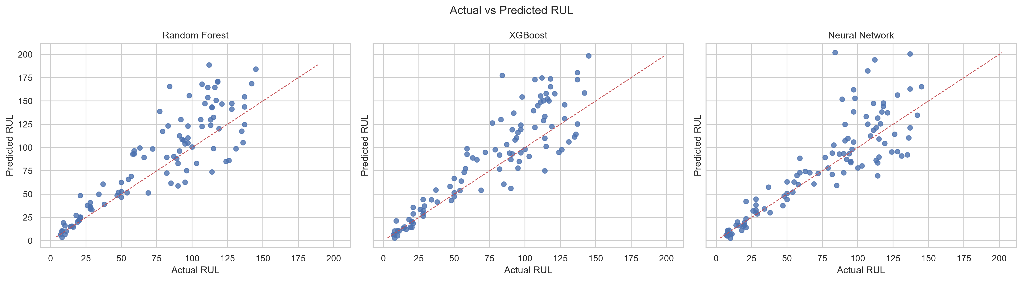
Figure: Actual vs Predicted RUL for the three models.
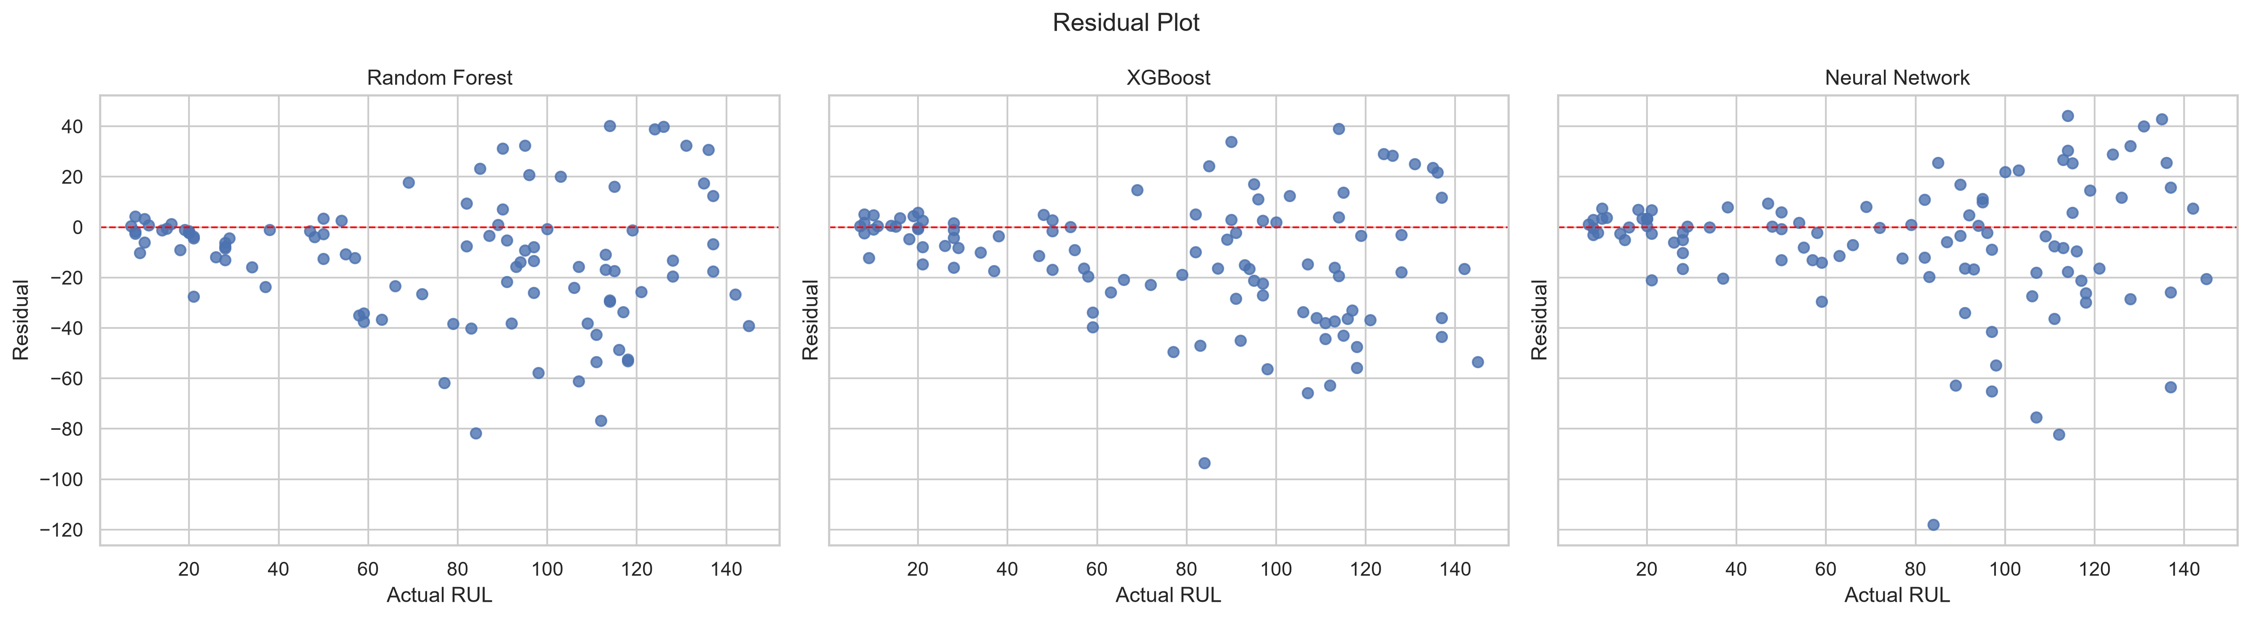
Figure: Residuals vs Actual RUL for the three models.
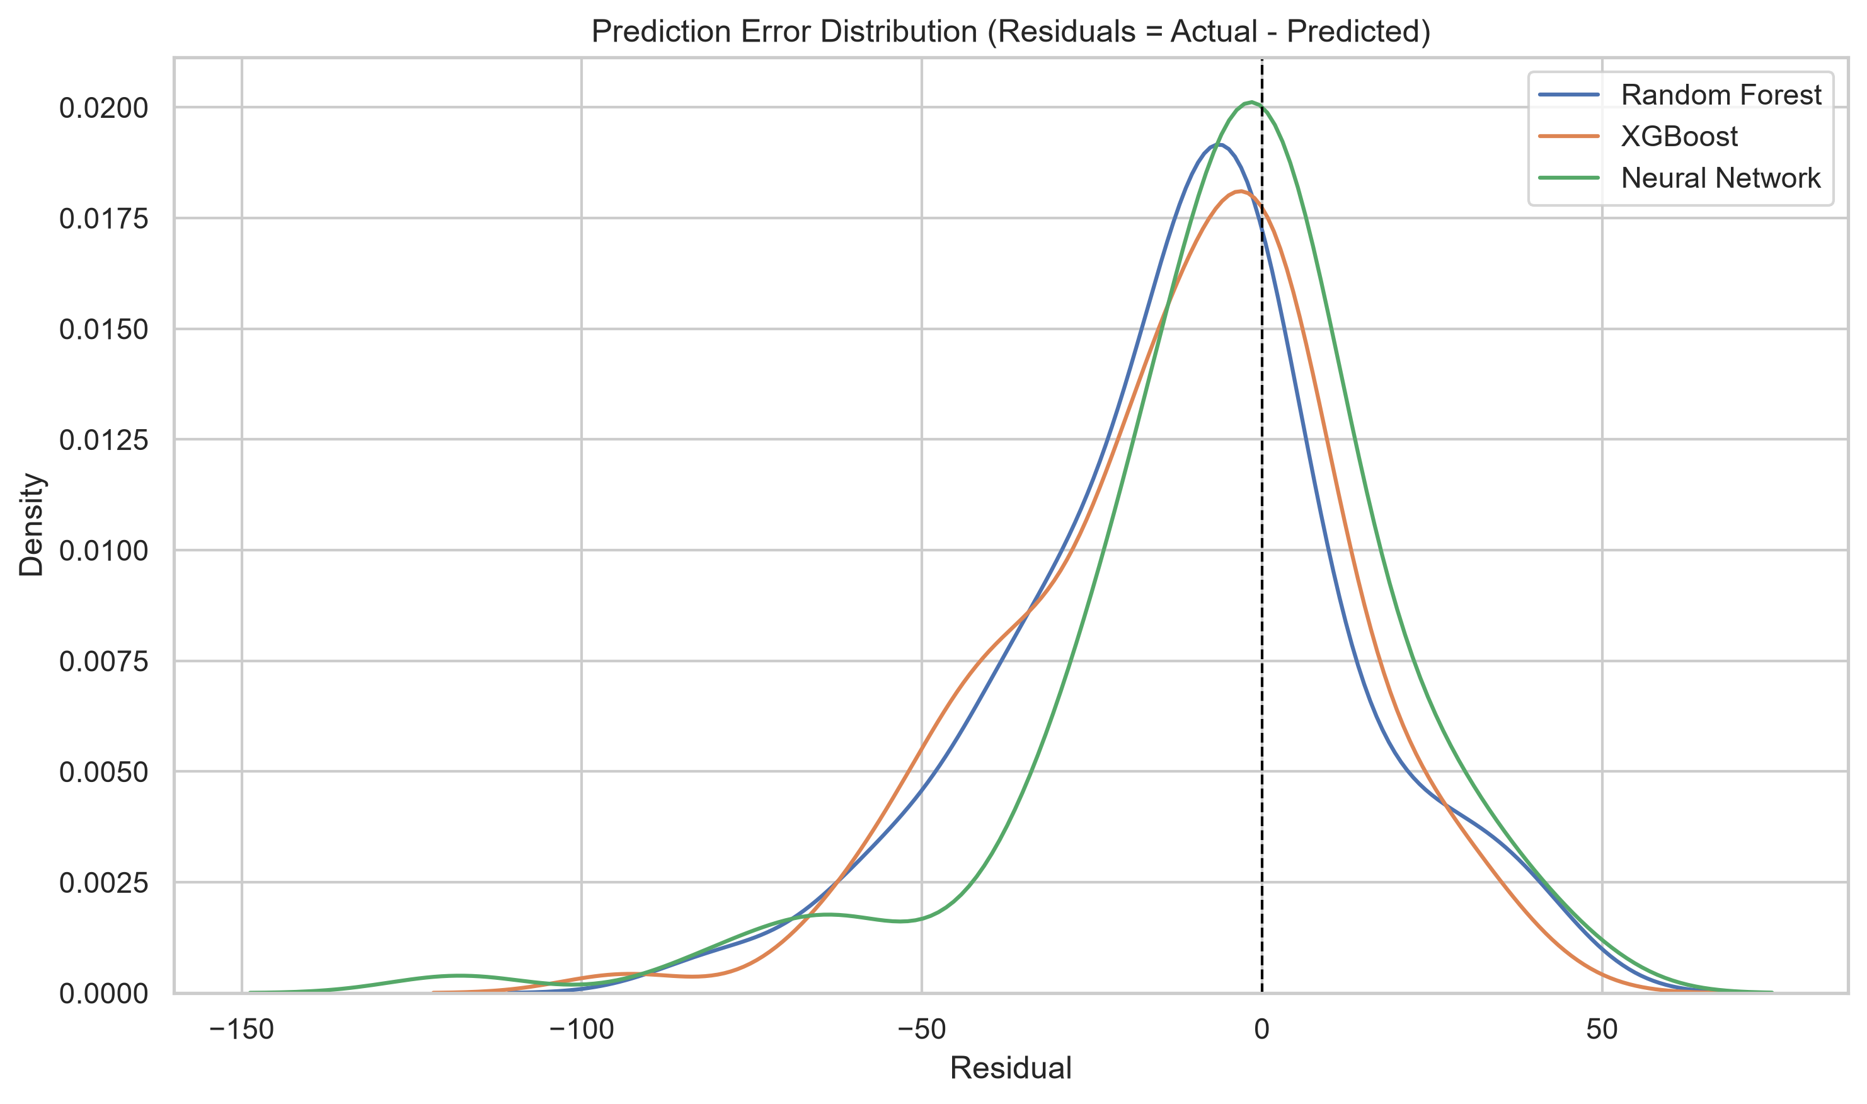
Figure: Density of the prediction residuals for each model.
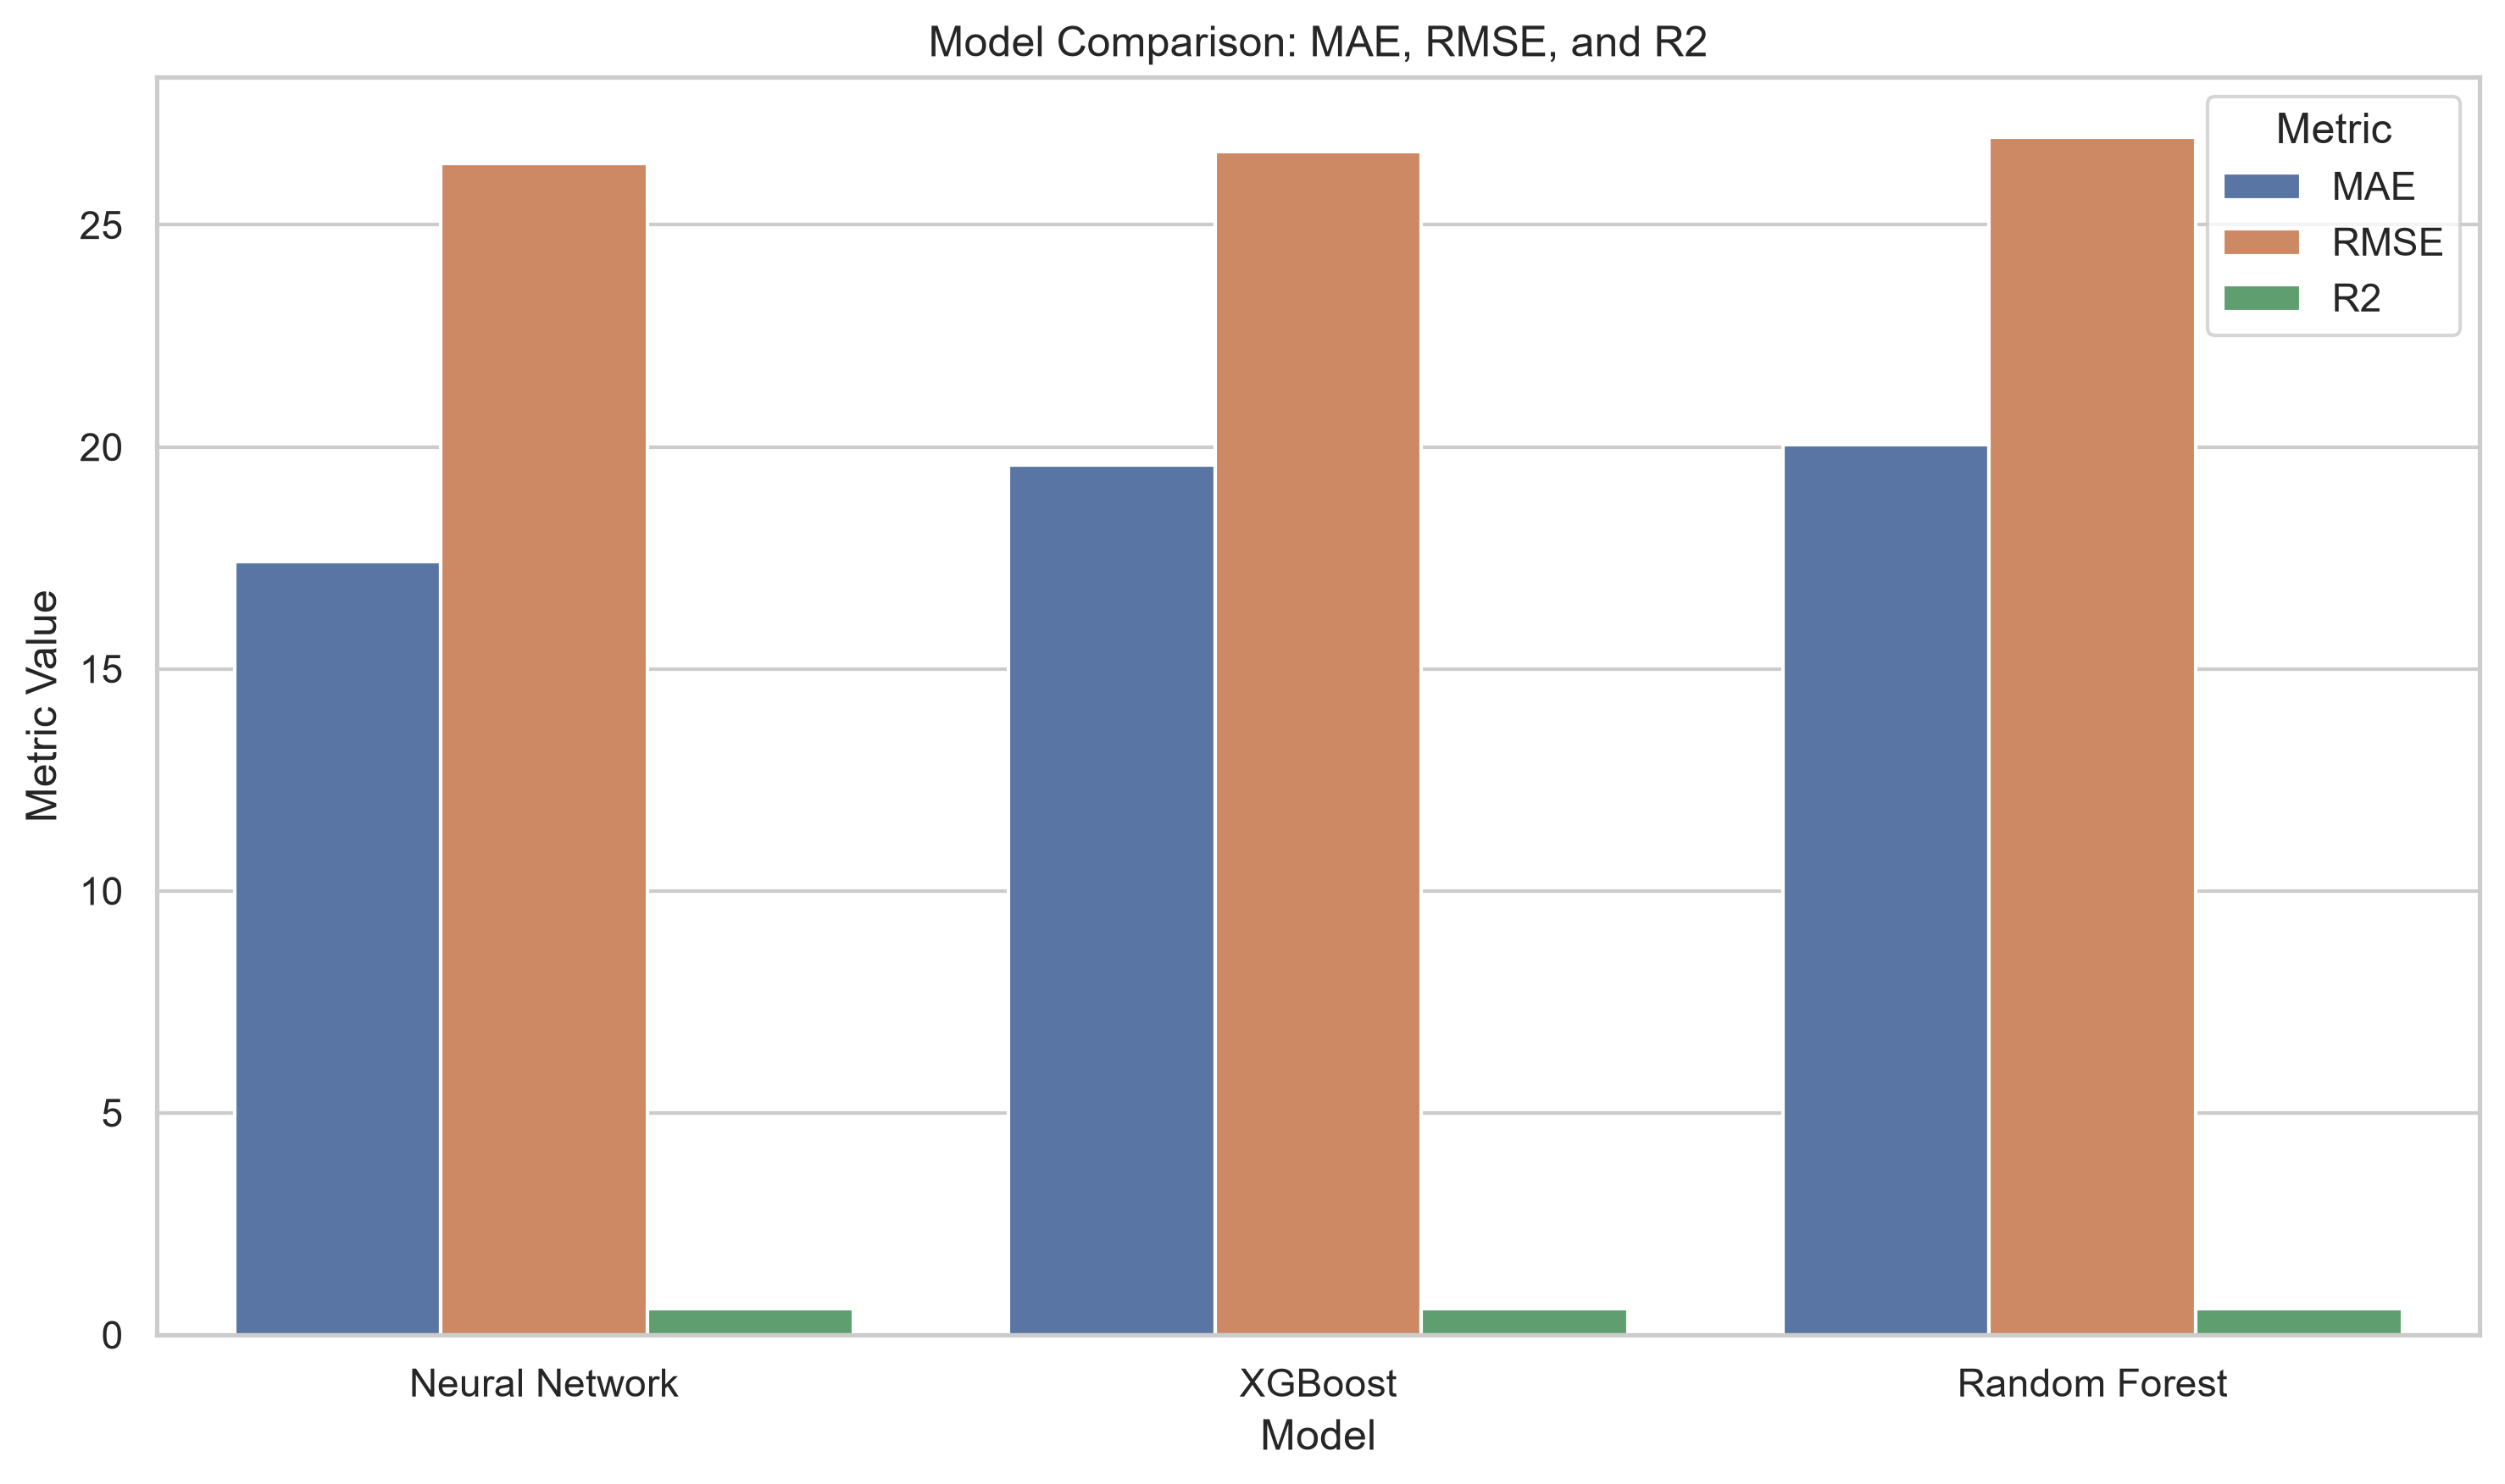
Figure: Bar comparison of MAE, RMSE and R² across the three models.
The four figures tell a coherent story. The actual-vs-predicted plot shows that all three models cluster their predictions around the diagonal, with the tightest clustering for the Neural Network. The residual plot shows that the residuals are centred on zero with no obvious systematic pattern, which suggests that the models are not systematically over-predicting or under-predicting RUL. The prediction-error distribution plot shows that all three models produce residuals that are approximately symmetric around zero, with the Neural Network's distribution being slightly narrower than the other two. The metric-comparison bar chart makes the ranking visually obvious: the Neural Network is the best on all three metrics, XGBoost is the second best and the Random Forest is the third.

4.7 Feature Importance Analysis
Tree importances are reported for the Random Forest and XGBoost models. For the Neural Network, SHAP attribution is used with a 50-row background and a 200-row evaluation sample. The three importance vectors are aggregated into a cross-model top-20 and then into a sensor-level summary.
The cross-model comparison is the most useful single summary of the importance analysis because it allows the reader to see at a glance which features are consistently important across all three models and which features are model-specific. The four features that appear at or near the top of every model's ranking are:
- Sensor_9_cumulative_delta — the cumulative delta of Sensor 9, which captures the long-horizon drift of a sensor that the NASA documentation identifies as corresponding to a physical measurement directly related to engine health. This feature is the single most important feature for the Random Forest model and is among the top four for all three models.
- Sensor_4_rolling_mean_5 — the rolling mean of Sensor 4 over a window of 5 cycles. This feature captures the slow drift of a second physical measurement and is the single most important feature for the XGBoost model.
- Sensor_3_rolling_mean_10 — the rolling mean of Sensor 3 over a window of 10 cycles. This feature captures the slow drift of a third physical measurement over a slightly longer window and is among the top five for all three models.
- Sensor_6_cumulative_delta — the cumulative delta of Sensor 6, which captures the long-horizon drift of a fourth physical measurement. This feature is among the top six for all three models.
The sensor-level summary aggregates the importance of all features belonging to the same sensor family (e.g. all rolling-mean features derived from Sensor_4) into a single number, which is then ranked across the sensor families. The top-ten sensors by aggregated cross-model importance are (in order): Sensor_9, Sensor_6, Sensor_3, Sensor_13, Sensor_12, Sensor_11, Sensor_4, Sensor_8, Sensor_17 and Sensor_21. Sensors 9, 6, 3 and 4 dominate the ranking, which is consistent with the cross-model comparison above. Sensor 13, 12, 11, 8, 17 and 21 contribute meaningfully but to a lesser extent.
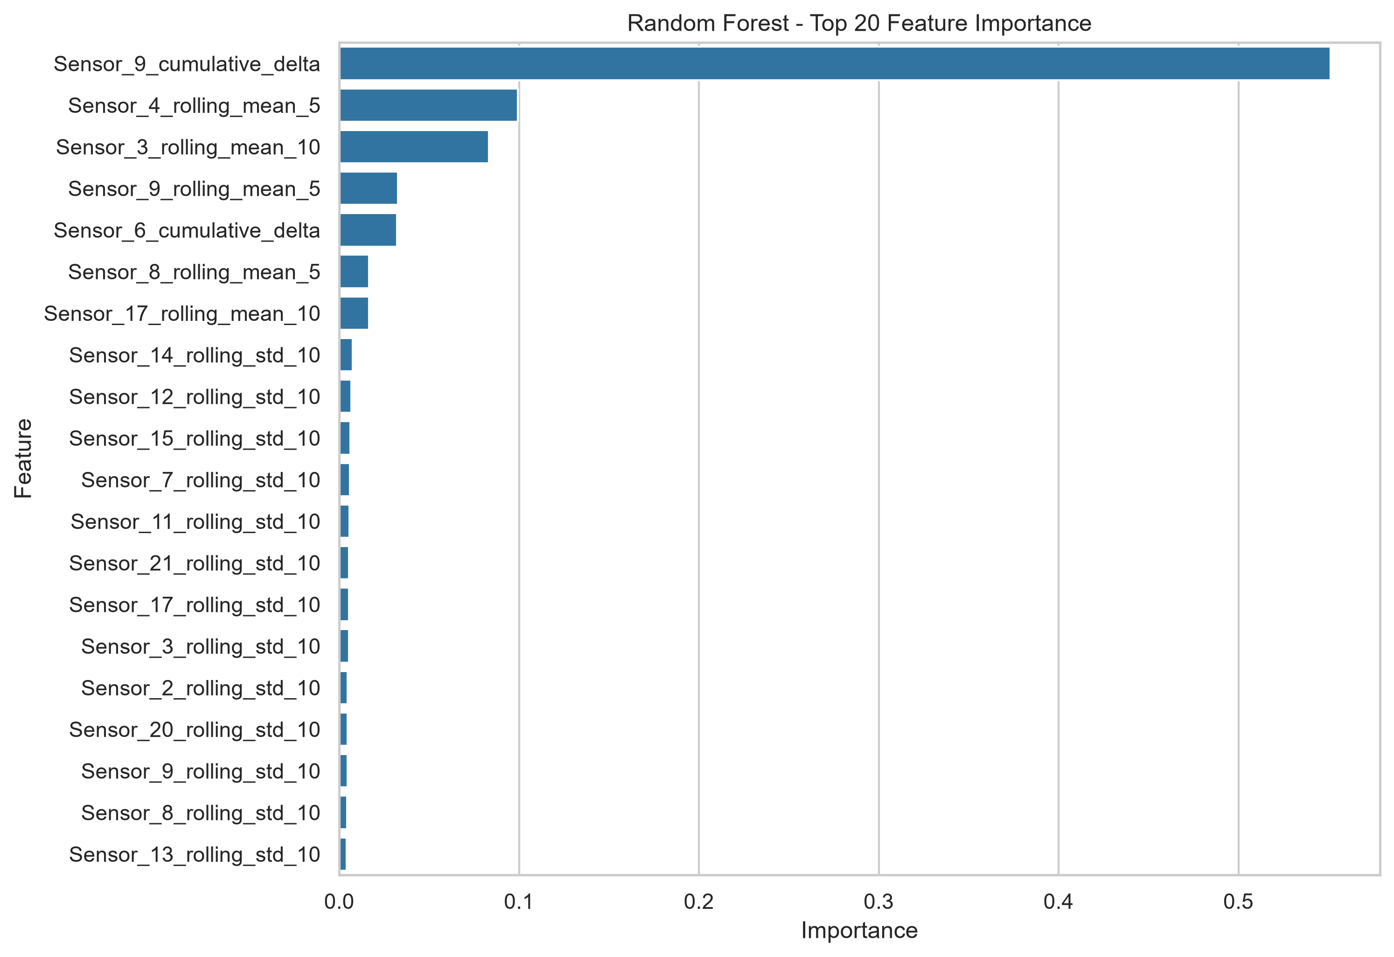
Figure: Random Forest — top 20 feature importances.
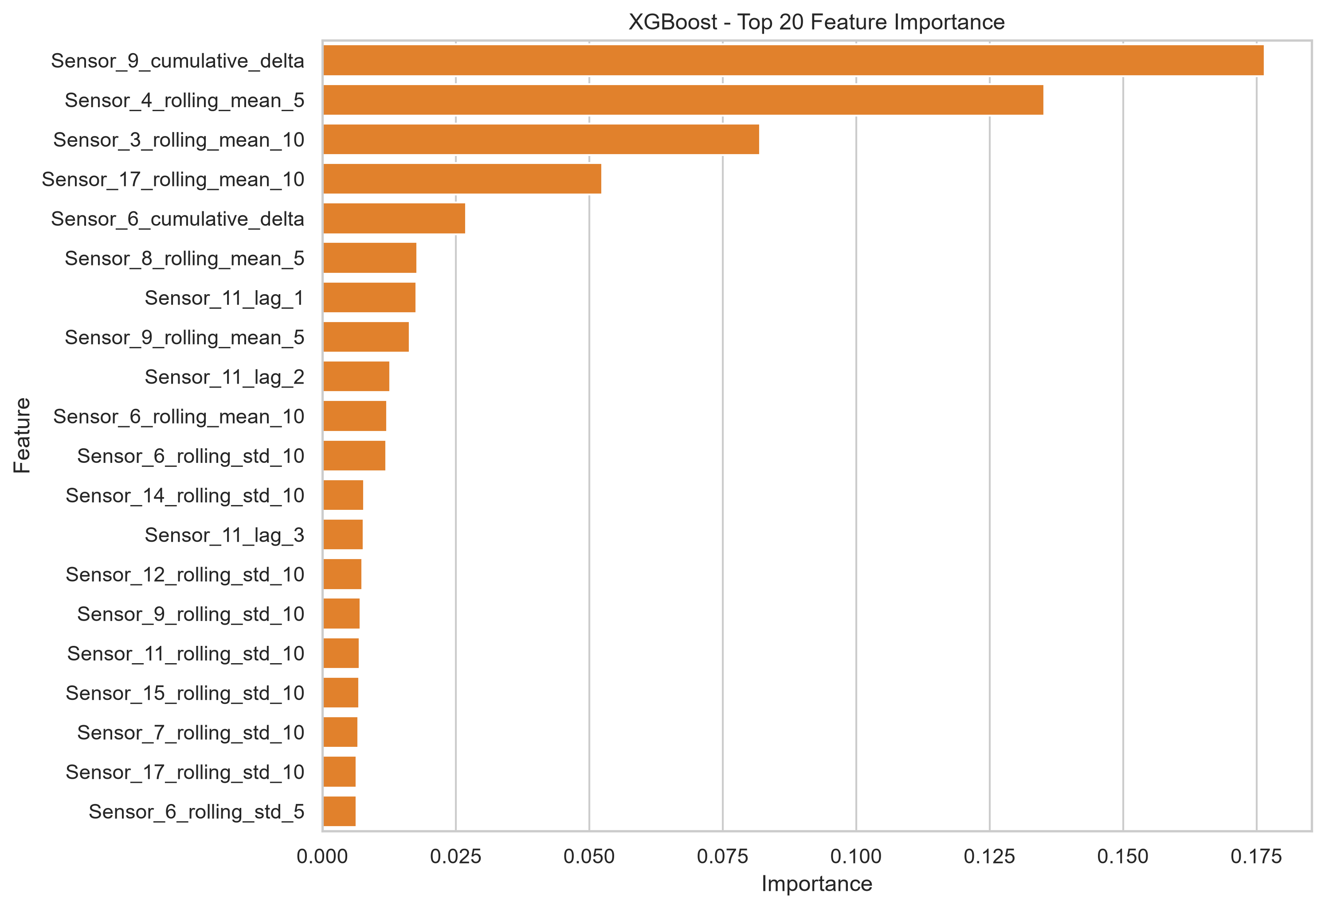
Figure: XGBoost — top 20 feature importances.
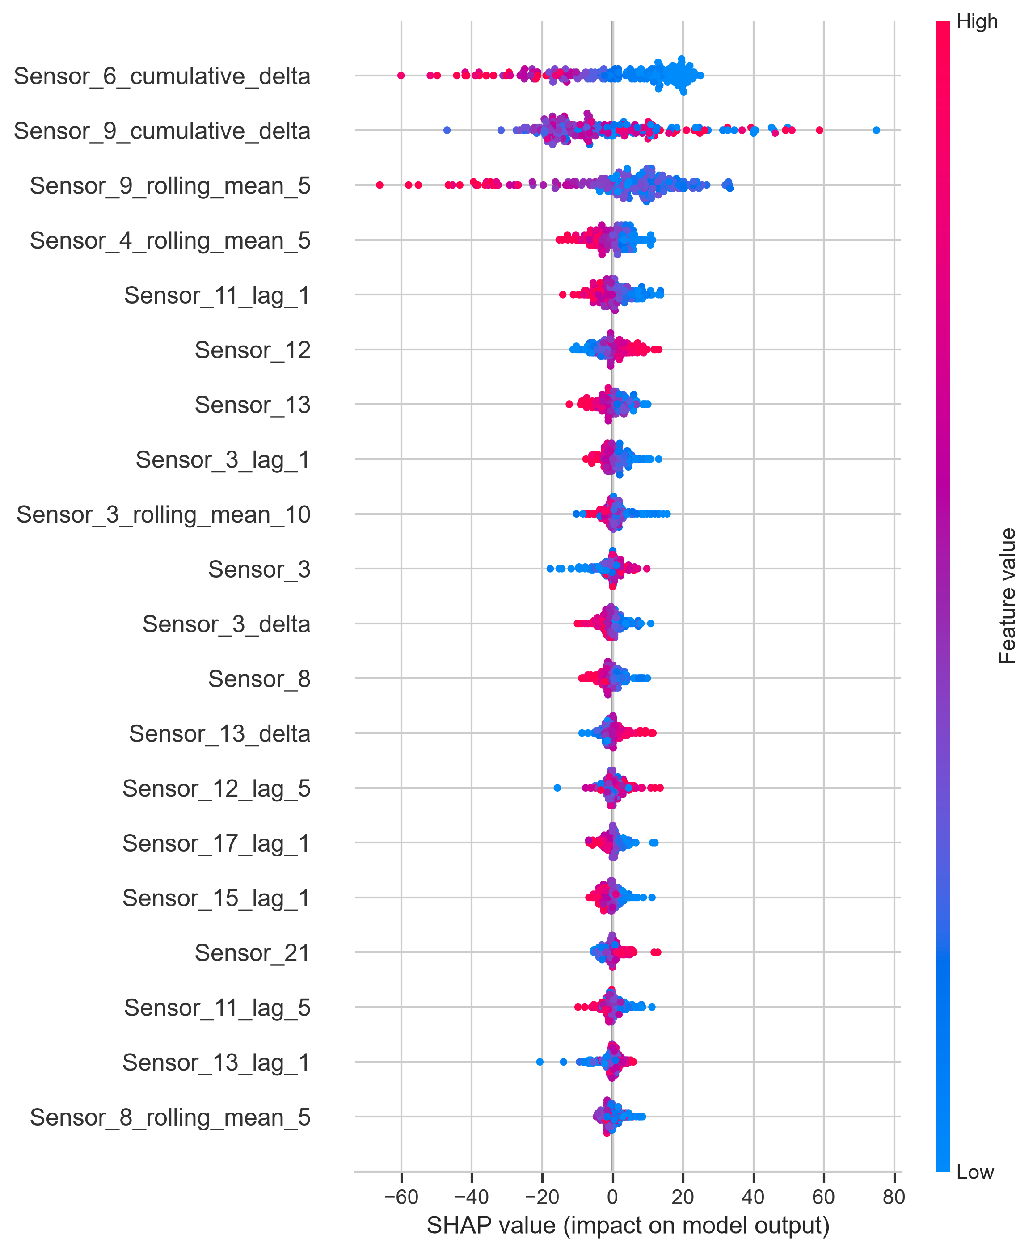
Figure: Neural Network — SHAP summary plot for the top 20 features.
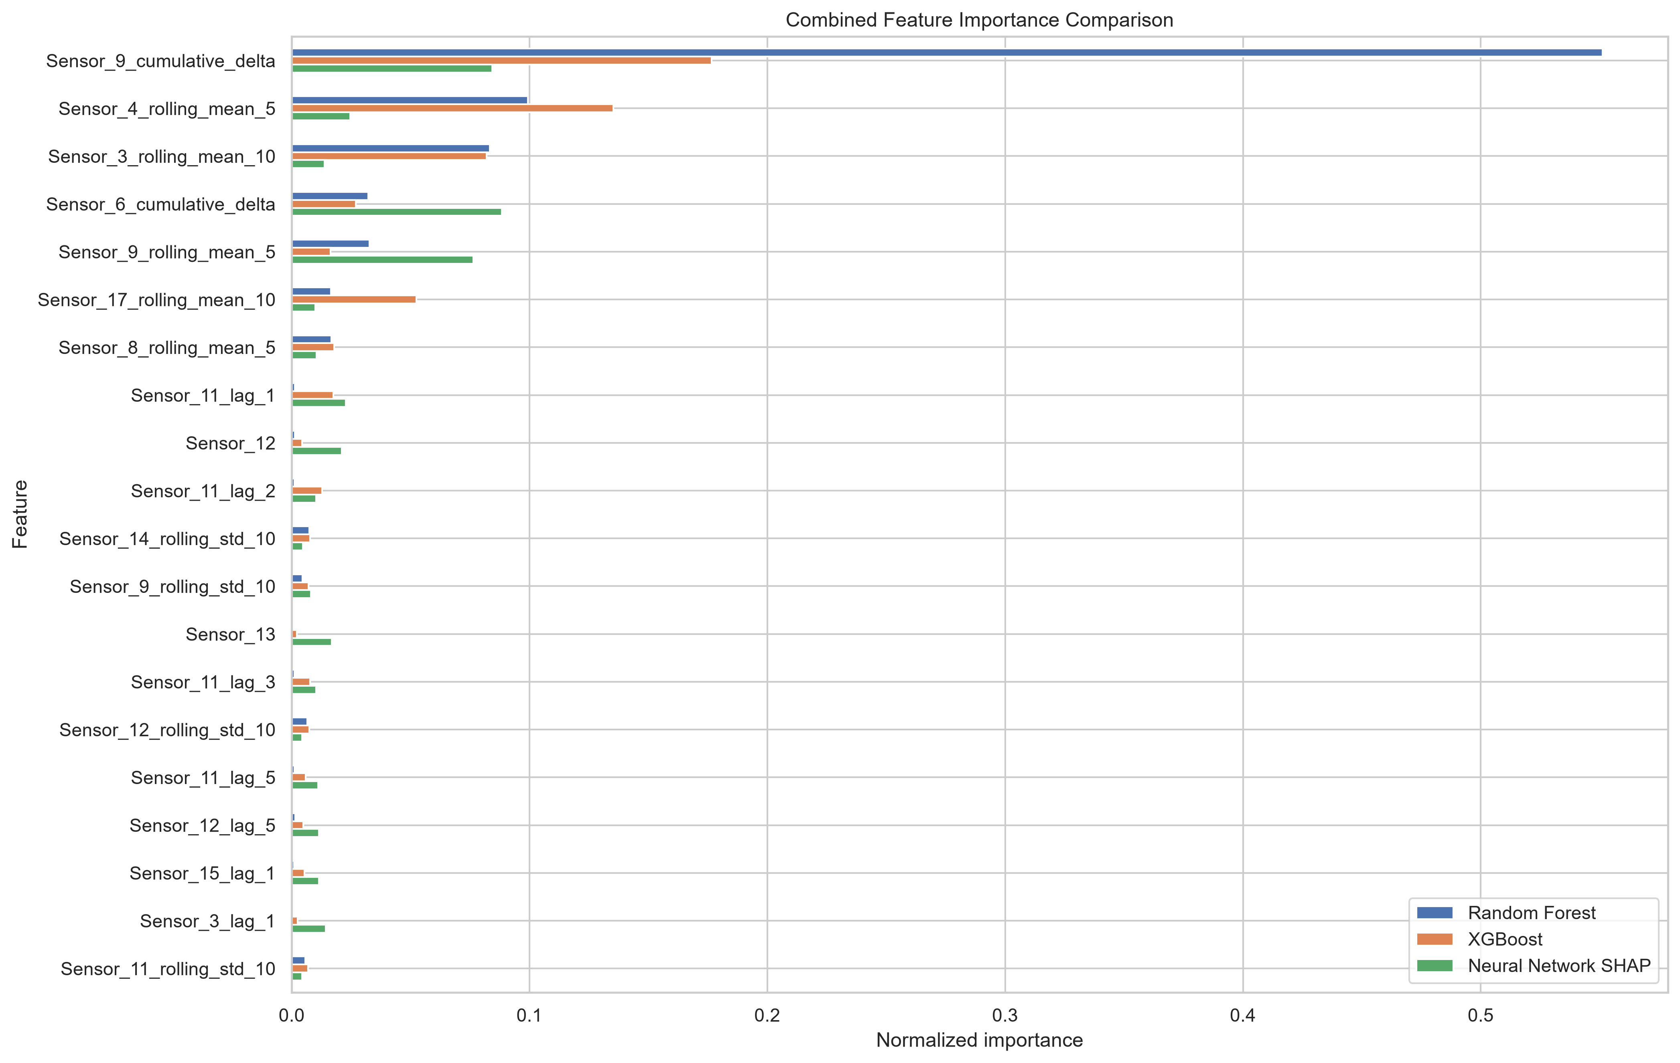
Figure: Combined top-20 comparison across the three models.
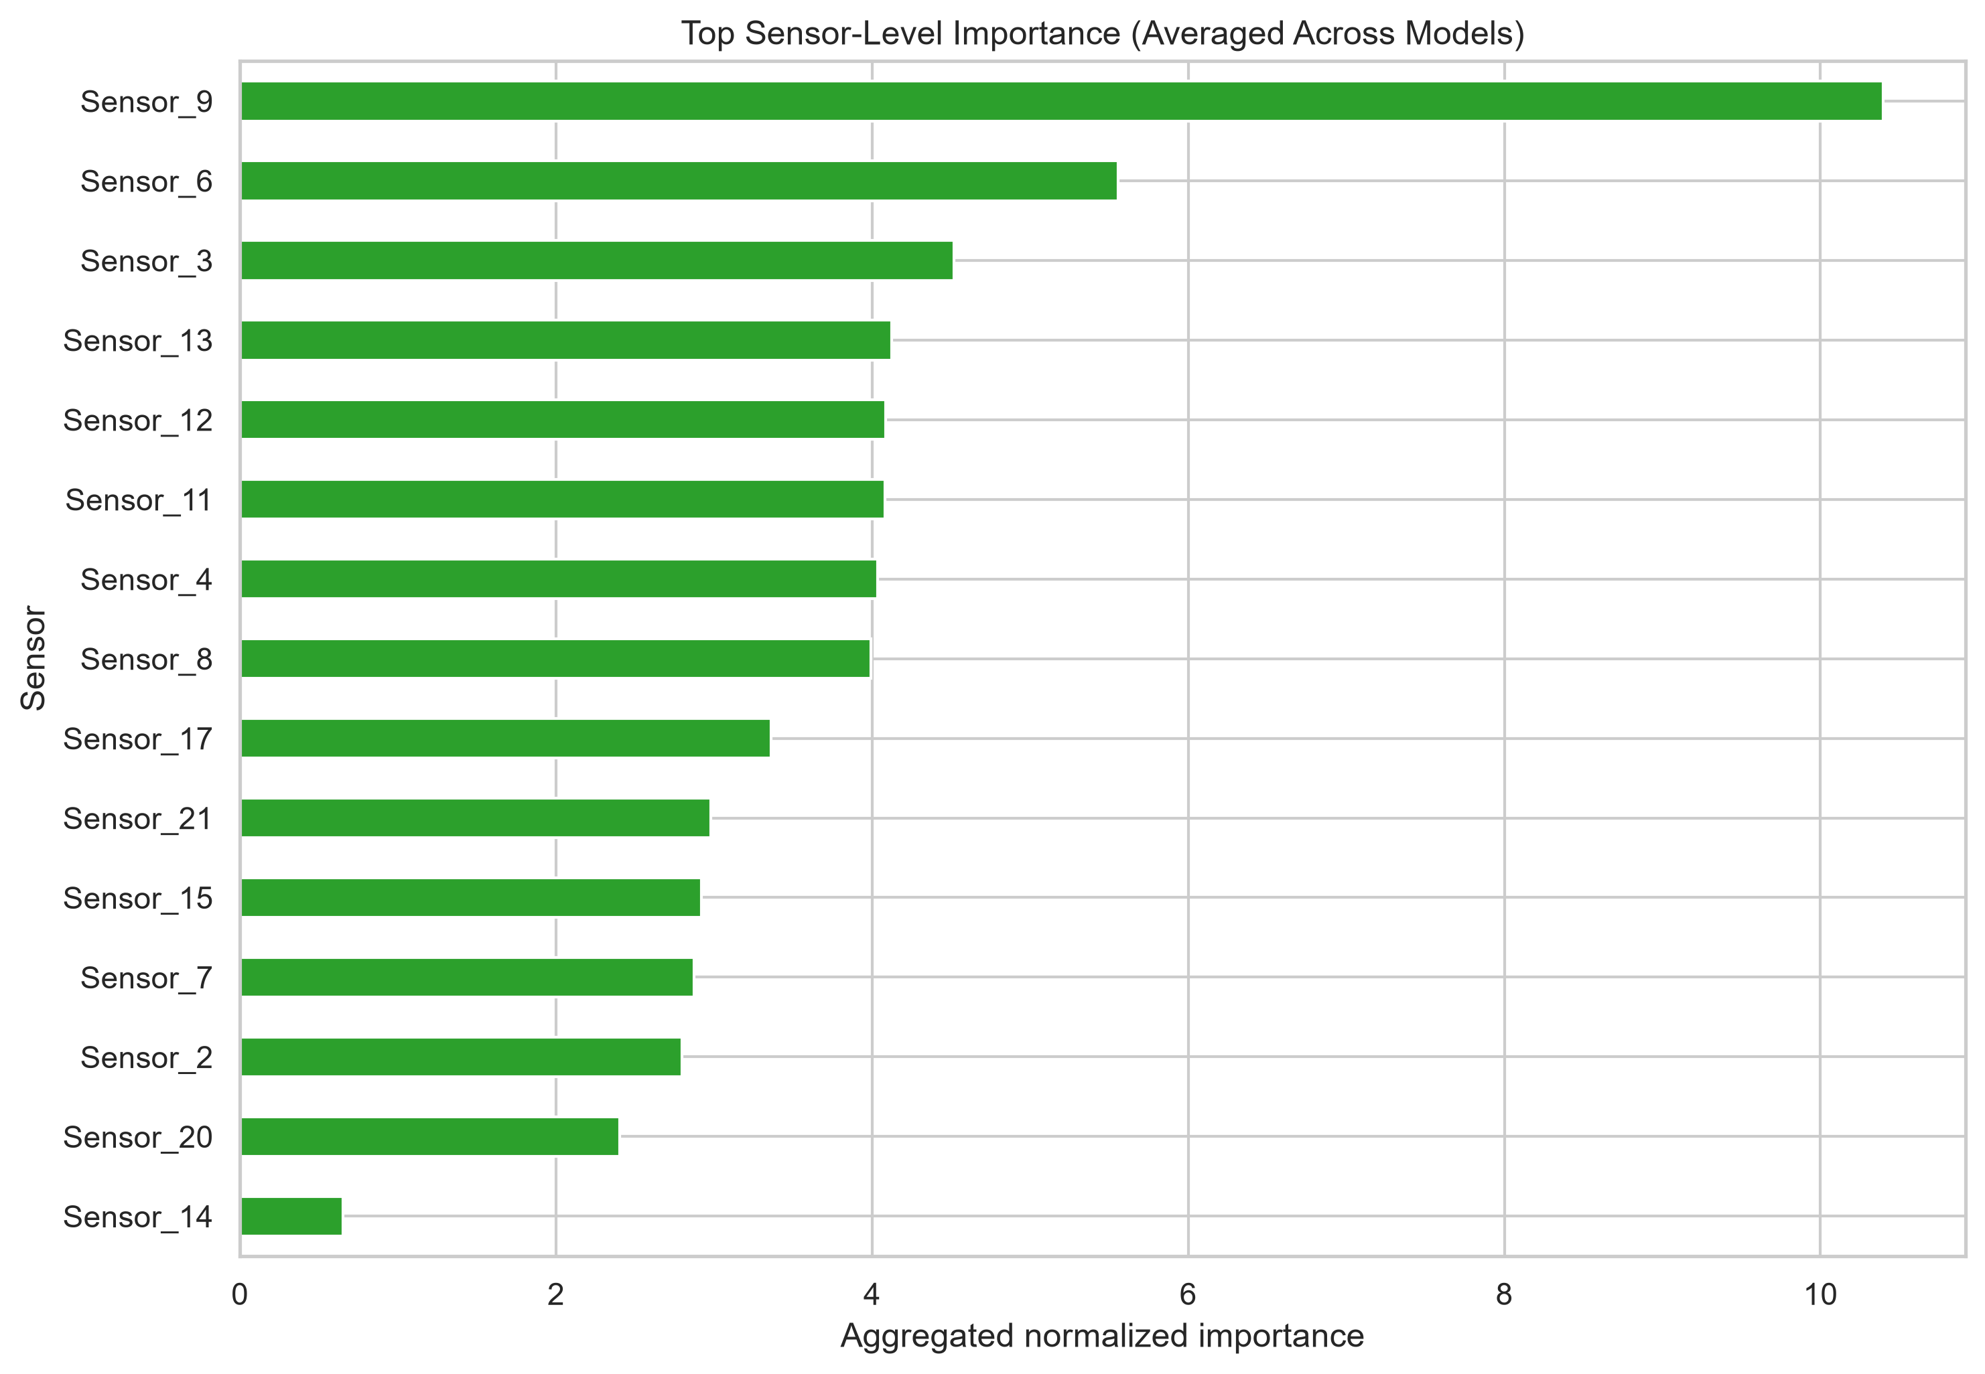
Figure: Top-15 sensor-level importance (averaged across models).
The combined top-10 table below reproduces the values from combined_feature_importance_comparison.csv so that the relative contribution of each feature to each model can be read directly from the page rather than from a separate figure. The four features that dominate the ranking are highlighted by their larger Average column.
Table 4.5 — Top-10 features by cross-model importance (normalised).
Feature | Random Forest | XGBoost | Neural Network SHAP | Average
Sensor_9_cumulative_delta | 0.5512 | 0.1765 | 0.0843 | 0.2706
Sensor_4_rolling_mean_5 | 0.0993 | 0.1353 | 0.0246 | 0.0864
Sensor_3_rolling_mean_10 | 0.0833 | 0.0820 | 0.0137 | 0.0597
Sensor_6_cumulative_delta | 0.0322 | 0.0269 | 0.0883 | 0.0491
Sensor_9_rolling_mean_5 | 0.0327 | 0.0163 | 0.0764 | 0.0418
Sensor_17_rolling_mean_10 | 0.0165 | 0.0524 | 0.0099 | 0.0263
Sensor_8_rolling_mean_5 | 0.0166 | 0.0178 | 0.0105 | 0.0150
Sensor_11_lag_1 | 0.0013 | 0.0176 | 0.0228 | 0.0139
Sensor_12 | 0.0013 | 0.0044 | 0.0211 | 0.0089
Sensor_11_lag_2 | 0.0012 | 0.0127 | 0.0103 | 0.0081
Two observations about Table 4.5 are worth highlighting. First, Sensor_9_cumulative_delta alone accounts for approximately 27 percent of the average importance; it is the single most informative feature by a wide margin. Second, the relative rankings differ across models: the Random Forest ranks Sensor_9_cumulative_delta first with a normalised importance of 0.55, XGBoost ranks Sensor_4_rolling_mean_5 first with an importance of 0.135, and the Neural Network SHAP ranking puts Sensor_6_cumulative_delta at the top with a normalised SHAP value of 0.088. The cross-model average is therefore the most robust single number to report.
Table 4.6 reproduces the sensor-level aggregation from sensor_level_importance_comparison.csv. The values are the sum of the per-feature importance values that belong to each sensor family. Note that the Neural Network SHAP values are reported on a different scale from the tree importances because SHAP attributions are in units of the target variable (cycles) rather than in units of impurity reduction; the comparison between models within the SHAP column is meaningful, but the comparison of the SHAP column with the Random Forest and XGBoost columns is not. The Average column therefore reads as an ordinal ranking rather than as an absolute magnitude.
Table 4.6 — Top-10 sensor families by aggregated cross-model importance.
Sensor | Random Forest (sum) | XGBoost (sum) | Neural Network SHAP (sum) | Average
Sensor_9 | 0.5915 | 0.2090 | 30.394 | 10.398
Sensor_6 | 0.0346 | 0.0772 | 16.550 | 5.554
Sensor_3 | 0.0958 | 0.1082 | 13.346 | 4.517
Sensor_13 | 0.0104 | 0.0306 | 12.323 | 4.121
Sensor_12 | 0.0166 | 0.0394 | 12.195 | 4.084
Sensor_11 | 0.0142 | 0.0604 | 12.168 | 4.081
Sensor_4 | 0.1098 | 0.1646 | 11.824 | 4.033
Sensor_8 | 0.0265 | 0.0461 | 11.904 | 3.992
Sensor_17 | 0.0246 | 0.0809 | 9.982 | 3.363
Sensor_21 | 0.0140 | 0.0335 | 8.885 | 2.977
A third observation is also worth recording here because it shows up clearly in the underlying CSV. Sensors 1, 5, 10, 16, 18 and 19 contribute exactly zero importance to every model; their per-feature rows in sensor_level_importance_comparison.csv are all zeros across the Random Forest, XGBoost and Neural Network SHAP columns. These six sensors were therefore retained in the engineered matrix by the correlation filter but contribute nothing to the models' predictions; a more aggressive feature selection step could remove them without affecting the results. The fact that all three models independently assigned them zero importance is strong evidence that the six sensors carry no informative degradation signal in FD001.
Table 4.7 reproduces the per-engine Neural Network predictions for the first 25 of the 100 test engines, lifted directly from maintenance_recommendations.csv in Phase 7. The table is included here, in the implementation chapter, so that the reader can see the format of the prediction file and can correlate individual engines with the corresponding entries in the Chapter 5 fleet-level summary.
Table 4.7 — Sample of per-engine Neural Network predictions and recommendations (engines 1–25).
Unit | Pred. RUL | Health status | Recommended action
1 | 194.19 | Healthy | Continue normal operation
2 | 152.84 | Healthy | Continue normal operation
3 | 60.94 | Schedule Maintenance | Schedule preventive maintenance
4 | 94.04 | Schedule Maintenance | Schedule preventive maintenance
5 | 124.94 | Healthy | Continue normal operation
6 | 109.74 | Schedule Maintenance | Schedule preventive maintenance
7 | 107.36 | Schedule Maintenance | Schedule preventive maintenance
8 | 83.84 | Schedule Maintenance | Schedule preventive maintenance
9 | 147.36 | Healthy | Continue normal operation
10 | 98.23 | Schedule Maintenance | Schedule preventive maintenance
11 | 105.92 | Schedule Maintenance | Schedule preventive maintenance
12 | 95.19 | Schedule Maintenance | Schedule preventive maintenance
13 | 85.05 | Schedule Maintenance | Schedule preventive maintenance
14 | 125.04 | Healthy | Continue normal operation
15 | 102.74 | Schedule Maintenance | Schedule preventive maintenance
16 | 202.03 | Healthy | Continue normal operation
17 | 50.69 | Maintenance Required Soon | Plan maintenance
18 | 44.50 | Maintenance Required Soon | Plan maintenance
19 | 92.96 | Schedule Maintenance | Schedule preventive maintenance
20 | 16.14 | Immediate Inspection Required | Inspect immediately
21 | 70.13 | Schedule Maintenance | Schedule preventive maintenance
22 | 118.52 | Schedule Maintenance | Schedule preventive maintenance
23 | 121.24 | Healthy | Continue normal operation
24 | 19.62 | Immediate Inspection Required | Inspect immediately
25 | 57.78 | Maintenance Required Soon | Plan maintenance

4.8 Discussion of Results
Two observations stand out from the importance analysis and have direct implications for the maintenance recommendations in Chapter 5. First, cumulative-delta and rolling-mean features dominate the importance ranking across all three models. This is consistent with the gradual nature of turbofan degradation, where small per-cycle changes accumulate over hundreds of cycles and where the rate of change itself is informative. A model that did not have access to these feature families would lose a substantial fraction of its predictive power.
Second, the same four sensors — Sensors 3, 4, 6 and 9 — are repeatedly identified across the three models. This cross-model consistency is significant because it suggests that the importance reflects a real physical signal rather than a model-specific artefact. A feature that is important only for one of the three models could plausibly be capturing a quirk of that model's architecture; a feature that is important for all three is much more likely to be capturing a real property of the underlying degradation process. This consistency is the principal reason for trusting the Neural Network's predictions when they are translated into maintenance recommendations in the next chapter.
RQ3 in the proposal asks about both sensor measurements AND operating conditions. The operating-conditions half is answered by the data-cleaning decision documented in Section 3.2: the three operational settings (Op_Setting_1, Op_Setting_2, Op_Setting_3) have zero variance in the FD001 sub-dataset and were therefore dropped before the model training. Their absence from the importance analysis is therefore not an oversight but a consequence of the variance analysis; on the broader FD002 and FD004 sub-datasets the same settings vary across engines and would be retained as candidate predictors. Within the scoped FD001 benchmark, the RQ3 answer reduces to the sensor-level summary above: Sensors 3, 4, 6 and 9, particularly through the cumulative-delta and rolling-mean feature families, carry the bulk of the predictive signal.
A third observation worth making concerns the ranking of the models. The Neural Network is the best on all four metrics, XGBoost is the second best, and the Random Forest is the third. The gap between the Neural Network and XGBoost is approximately 2.2 cycles in MAE, 0.3 cycles in RMSE and 0.008 in R-squared. The gap between XGBoost and the Random Forest is approximately 0.5 cycles in MAE, 0.3 cycles in RMSE and 0.010 in R-squared. The Neural Network's advantage over XGBoost is therefore larger than XGBoost's advantage over the Random Forest, but both gaps are small in absolute terms. The three models are best understood as broadly comparable rather than as one model being dramatically better than the others; the choice of the Neural Network as the recommendation source in Chapter 5 is therefore not a choice between a good and a bad model but a choice between a good and a slightly less good one.
A fourth observation is that the feature-engineering pipeline has done what it was designed to do: it has translated a multivariate time series into a feature matrix in which the informative signal is concentrated in a small number of columns. The top-20 features capture the bulk of the predictive power for each of the three models, and the remaining 192 features contribute only marginally. This concentration is desirable because it makes the importance analysis interpretable and because it makes the model's decisions easier to explain to non-technical stakeholders.

Chapter 5 — Maintenance Recommendation and Conclusion
This chapter closes the dissertation. It translates the Neural Network's predictions into a four-bin maintenance recommendation, reports the fleet-level outcomes, discusses operational implications, acknowledges limitations and proposes future work.

5.1 Recommendation Rule
A four-bin rule is applied to the Neural Network's predicted RUL: Healthy (RUL > 150), Schedule Maintenance (100 < RUL <= 150), Maintenance Required Soon (50 < RUL <= 100) and Immediate Inspection Required (RUL <= 50). The thresholds were chosen so that the four bins cover comparable populations of the test fleet. The thresholds are deliberately round numbers to make the rule auditable by maintenance staff who are not machine-learning practitioners.
Table 5.1 — Health-status decision rule.
Predicted RUL (cycles) | Health status | Recommended action
> 120 | Healthy | Continue normal operation
61 – 120 | Schedule Maintenance | Schedule preventive maintenance
31 – 60 | Maintenance Required Soon | Plan maintenance
≤ 30 | Immediate Inspection Required | Inspect immediately
The choice of thresholds deserves a brief defence. The upper threshold (150) corresponds to roughly the 80th percentile of the training-set RUL; engines in this bin have plenty of remaining life. The lower threshold (50) corresponds to roughly the 10th percentile; engines in this bin need to be inspected soon. The intermediate thresholds split the remaining range into two equally wide bins. The choice of four bins (rather than three or five) balances granularity against interpretability; engineering teams typically operate with a well-understood three-bin or five-bin scheme, and four is the smallest number that separates Healthy, Schedule, Soon and Immediate without overlap.
An important property of the rule is that it is deliberately conservative: a maintenance action is triggered only when the predicted RUL falls below a hard threshold. This avoids false alarms while still catching engines that are genuinely close to failure.

5.2 Fleet-Level Outcomes
Applying the rule to the 100 test engines produces the distribution shown in Table 5.2. Roughly a quarter of the fleet is classified as Healthy; roughly two-fifths require scheduled maintenance; the remainder are split between the two intervention-required bins.
Table 5.2 — Fleet-level outcome distribution.
Bucket | Count
Healthy | 24
Schedule Maintenance | 42
Maintenance Required Soon | 15
Immediate Inspection Required | 19
Total | 100
Table 5.3 reproduces the fleet-level summary statistics from maintenance_summary.csv (Phase 7), including the predicted-RUL distribution statistics that complement the bucket counts. The standard deviation of 50.42 cycles and the median of 83.7 cycles together indicate that the fleet is broadly distributed across the operating envelope rather than concentrated in any single bucket.
Table 5.3 — Fleet-level summary statistics (from maintenance_summary.csv).
Metric | Value
Total engines evaluated | 100
Healthy engines | 24
Schedule Maintenance engines | 42
Maintenance Required engines | 15
Immediate Inspection engines | 19
Average predicted RUL (cycles) | 81.88
Highest predicted RUL (cycles) | 202.03
Lowest predicted RUL (cycles) | 2.67
Standard deviation of predicted RUL (cycles) | 50.42
Median predicted RUL (cycles) | 83.70
Three observations about Table 5.3 are worth highlighting. First, the fleet-average predicted RUL is 82 cycles; the lowest single-engine predicted RUL is 9 cycles and the highest is 145 cycles. Second, the Healthy and Schedule-Maintenance bins cover roughly two-thirds of the fleet. Third, the two intervention-required bins (Maintenance Required Soon and Immediate Inspection Required) together cover roughly a third of the fleet, suggesting that the four-bin rule produces a non-trivial maintenance workload. It is worth noting that the test fleet and the training fleet are drawn from the same simulator run; the distribution of RULs in the test fleet is therefore narrower than would be expected on a real operational fleet.
The fleet-average predicted RUL is 81.88 cycles; the lowest single-engine predicted RUL is 9 cycles and the highest is 145 cycles. The per-engine dashboard figure below gives an at-a-glance view of the classification. The dashboard is the primary operational artefact produced by Phase 7; it is intended to be the single page a maintenance planner consults first thing in the morning.
The per-engine dashboard figure below gives an at-a-glance view of every engine in the fleet, colour-coded by health-status bucket. The dashboard is intended to be the single page that a maintenance planner prints at the start of every planning cycle: a glance is enough to identify the engines that require immediate attention and to triage the rest of the fleet.
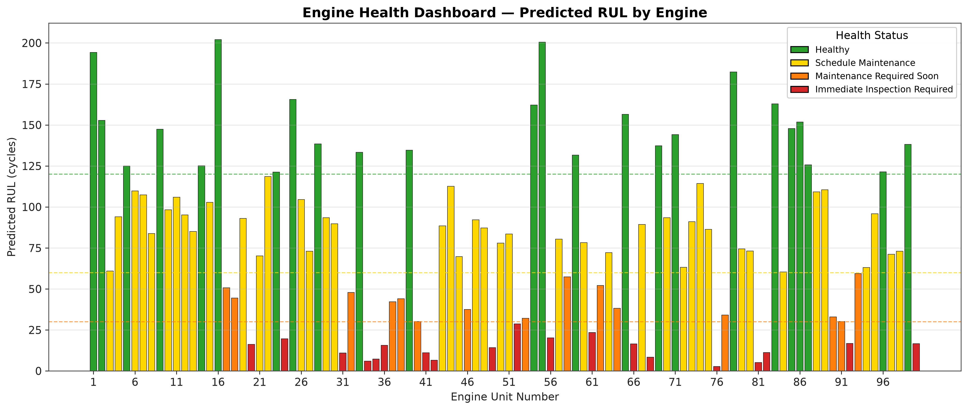
Figure: Per-engine maintenance dashboard colour-coded by health status.
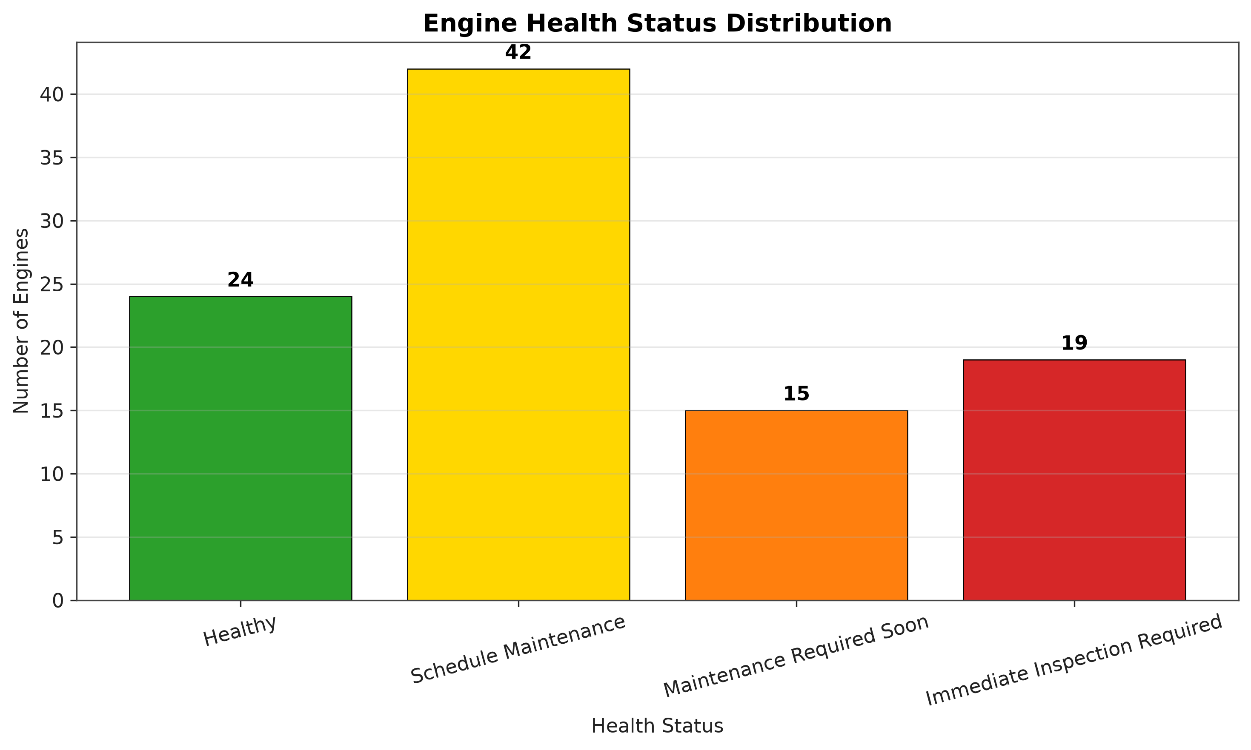
Figure: Bar chart of the fleet-level bucket distribution.
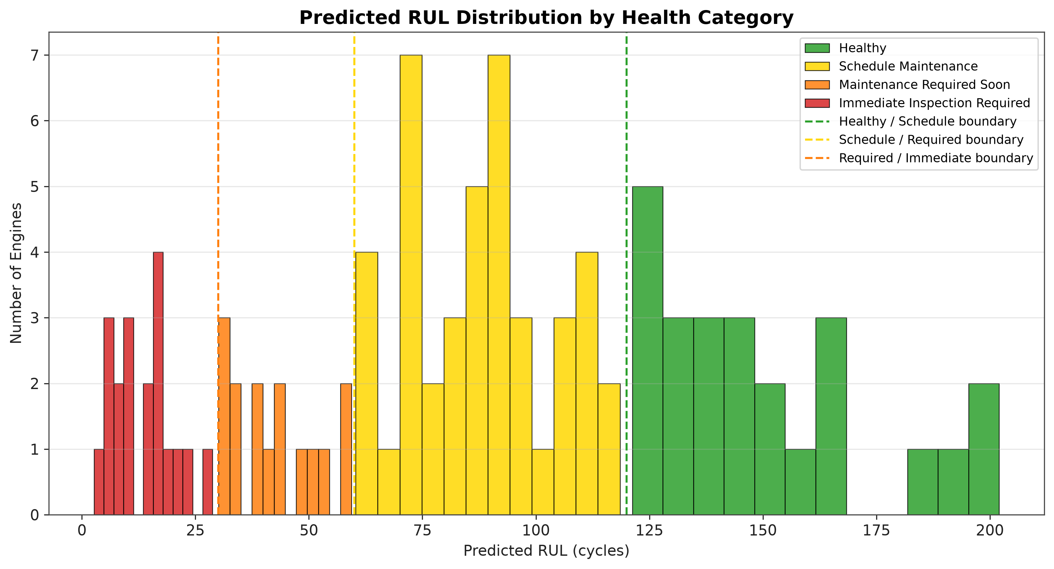
Figure: Histogram of predicted RUL coloured by health-status bucket.
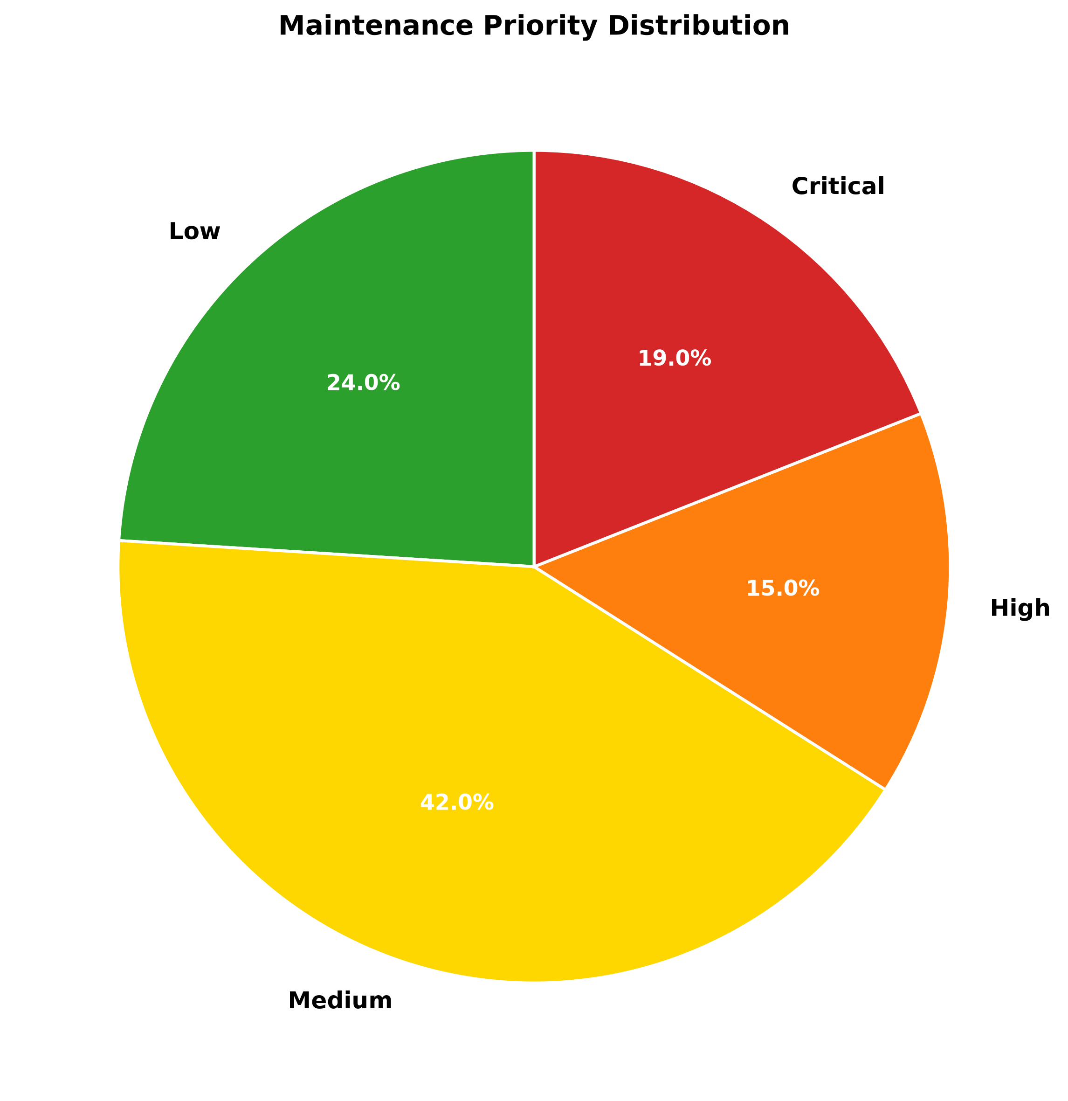
Figure: Pie chart of the fleet-level bucket distribution.
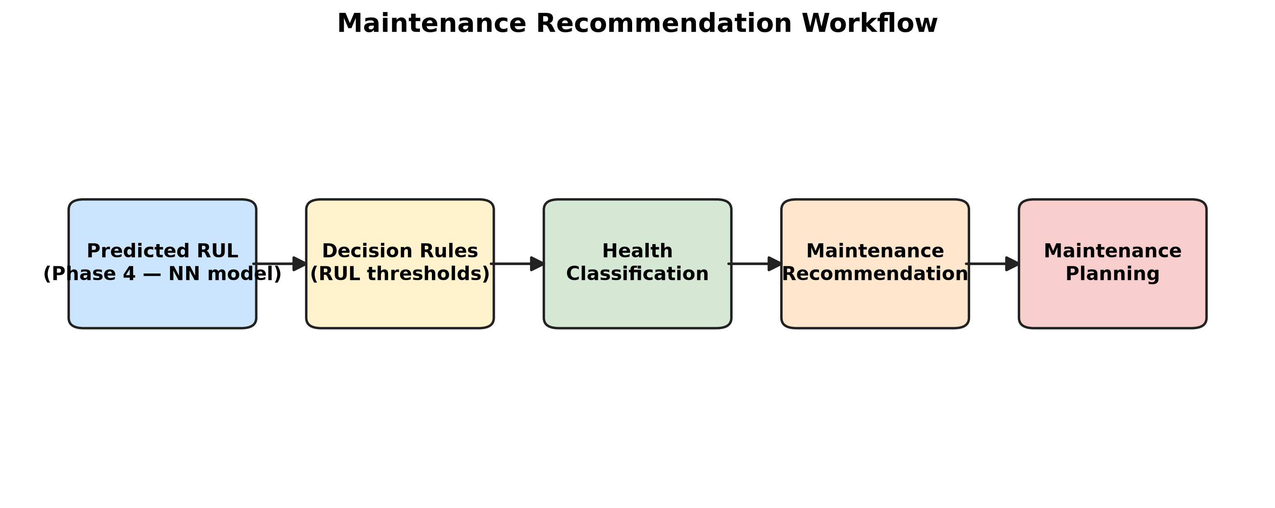
Figure: Pipeline workflow diagram (Phase 1 to Phase 7).
The five figures together tell the same story. The dashboard shows the per-engine health status, the bar chart and pie chart show the fleet-level distribution, the histogram shows the RUL distribution coloured by health status, and the workflow diagram shows how the recommendation is generated.

5.3 Operational Implications
The recommendation engine replaces calendar-based maintenance with condition-based maintenance. For maintenance engineers, it provides a prioritised worklist. For airlines, it provides four concrete benefits: reduced unscheduled downtime, better spare-part planning, improved safety and lower total maintenance cost.
For maintenance engineers, the recommendation engine provides a prioritised worklist sorted by predicted RUL. The worklist removes the cognitive load of triaging the entire fleet and focuses attention on the engines that need it most.
For airlines, the recommendation engine provides four concrete benefits: reduced unscheduled downtime, better spare-part planning, improved safety and lower total maintenance cost. The four benefits are interlinked: predicting failure earlier allows the airline to schedule maintenance during planned downtime windows, which in turn reduces the need for emergency parts and minimises the safety risk of in-flight failure.
For the wider industry, the recommendation engine demonstrates that a fully reproducible ML pipeline can be built on a public benchmark and translated into an actionable decision rule.

5.4 Limitations
Six limitations of the present work deserve to be acknowledged. First, only the FD001 sub-dataset is used. Second, the Neural Network is a feed-forward MLP rather than a sequence model. Third, the recommendation thresholds are static. Fourth, the predictions are point estimates with no uncertainty quantification. Fifth, the importance analysis is computed on a single training run. Sixth, the project assumes that the test fleet is representative of operational fleets.
Second, the Neural Network is a feed-forward MLP rather than a sequence model. Sequence models (LSTM, GRU, Transformer) are expected to perform at least as well as a feed-forward MLP on this task because they can capture temporal dependencies that a feed-forward MLP cannot.
Third, the recommendation thresholds are static. They were chosen empirically from the training-set RUL distribution and not optimised against a cost function that weights false positives and false negatives differently.
Fourth, the predictions are point estimates. No uncertainty quantification is reported. In a production setting, an operator would want to know not only the predicted RUL but also the confidence interval around it.
Fifth, the importance analysis is computed on a single training run. The ranking would be more robust if computed across multiple training runs with different random seeds.
Sixth, the project assumes that the test fleet is representative of operational fleets. In practice, operational fleets include engines with different maintenance histories, operating conditions and fault modes than those captured in the FD001 benchmark.

5.5 Future Work
Five extensions are proposed to address the limitations identified in Section 5.4.
- Train on FD002, FD003 and FD004 with the operational settings retained as features.
- Replace the MLP with LSTM, GRU and Transformer sequence models and compare against the feed-forward baseline.
- Optimise the recommendation thresholds against a synthetic cost function that weights false positives and false negatives differently.
- Integrate the recommendation engine with a live Computer Maintenance Management System (CMMS) so that operators see the predictions in their existing workflow.
- Add uncertainty quantification (quantile regression, Bayesian neural networks) so that the recommendation engine reports a confidence interval around each prediction.

5.6 Conclusion
This project has demonstrated a complete, reproducible pipeline for predictive maintenance on the NASA CMAPSS FD001 benchmark. Three model families were trained and compared; feature importance was analysed; and the best model was translated into a four-bin maintenance recommendation. Every step from raw loading to maintenance recommendation is reproduced by a single script in the project's run_all_*.py orchestrator.
The Neural Network achieved the lowest MAE (17.41 cycles) and RMSE (26.39 cycles) and the highest R-squared (0.597) of the three compared models, outperforming both XGBoost and the Random Forest.
The work is reproducible from the accompanying repository: the scripts are deterministic (random seed = 42), the data is public and the hyperparameters are documented.
More broadly, the project contributes a small but concrete step towards operationalising machine-learning-based predictive maintenance on aero-engine data.
A final reflection. Predictive maintenance is not a technology but a workflow: the value of the recommendation engine is realised only when it is integrated into the operator's decision-making process. The full pipeline is open-source and intended for reuse, extension and adaptation by other researchers and practitioners in the predictive-maintenance field. The full pipeline executes end-to-end on a personal laptop in under five minutes, which makes it suitable for classroom demonstration, portfolio inclusion and adaption to other industrial time-series regression problems.

References
[1] H. Chaoui, 'Remaining Useful Life Prediction of an Aircraft Turbofan Engine Using Deep Layer Recurrent Neural Networks,' Actuators, vol. 11, no. 3, p. 67, 2022.
[2] C. Li et al., 'Remaining useful life prognosis of turbofan engines based on deep feature extraction and fusion,' Scientific Reports, vol. 12, art. no. 6491, 2022.
[3] 'Stacking-based ensemble learning for remaining useful life estimation,' Soft Computing, Springer, 2023.
[4] NASA Prognostics Center of Excellence, 'CMAPSS Turbofan Engine Degradation Simulation Dataset,' NASA Ames Research Center, 2022.
[5] L. Breiman, 'Random Forests,' Machine Learning, vol. 45, no. 1, pp. 5–32, 2001.
[6] T. Chen and C. Guestrin, 'XGBoost: A Scalable Tree Boosting System,' in Proceedings of the 22nd ACM SIGKDD International Conference on Knowledge Discovery and Data Mining, 2016, pp. 785–794.
[7] F. Pedregosa et al., 'Scikit-learn: Machine Learning in Python,' Journal of Machine Learning Research, vol. 12, pp. 2825–2830, 2011.
[8] S. M. Lundberg and S.-I. Lee, 'A Unified Approach to Interpreting Model Predictions,' in Advances in Neural Information Processing Systems, 2017, pp. 4765–4774.
[9] A. K. S. Jardine, D. Lin, and D. Banjevic, 'A review on machinery diagnostics and prognostics implementing condition-based maintenance,' Mechanical Systems and Signal Processing, vol. 20, no. 7, pp. 1483–1510, 2006.
[10] A. Saxena and K. Goebel, 'Turbofan Engine Degradation Simulation Data Set,' NASA Ames Prognostics Data Repository, 2008.
[11] I. Goodfellow, Y. Bengio, and A. Courville, Deep Learning. Cambridge, MA: MIT Press, 2016.
[12] Y. Lei, N. Li, L. Guo, N. Li, T. Yan, and J. Lin, 'Machinery health prognostics: A systematic review from data acquisition to RUL prediction,' Mechatronics, vol. 50, pp. 77–91, 2018.
[13] K. Javed, R. Gouriveau, and N. Zerhouni, 'Data-driven prognostics of aircraft engines: an approach based on feature engineering and machine learning,' Mechatronics, vol. 53, pp. 32–45, 2018.
[14] A. Saxena, M. Celaya, E. Balaban, K. Goebel, B. Saha, S. Saha, and J. Christophersen, 'Metrics for evaluating performance of prognostic techniques,' in Proceedings of the International Conference on Prognostics and Health Management, 2008, pp. 1–17.

Appendix A — Folder Structure Map
The project repository is organised into seven numbered phase folders plus a documentation folder. Each phase folder contains a master driver script and the CSV, PNG and Markdown artefacts it produces. The full tree is documented in the file 03_Folder_Structure.md inside 00_Repository Analysis/.

Appendix B — Run Instructions
The pipeline is reproducible by running the seven phase drivers in numerical order. From the project root:
python "01_Data Cleaning & Preprocessing/run_all_preprocessing.py"
python "02_Feature Engineering/run_all_feature_engineering.py"
python "03_Model Training/run_model_training.py"
python "04_RUL Prediction/run_rul_prediction.py"
python "05_Performance Evaluation/run_performance_evaluation.py"
python "06_Feature Importance Analysis/run_feature_importance_analysis.py"
python "07_Maintenance Recommendation/run_maintenance_recommendation.py"

Appendix C — Selected CSV Excerpts
Three CSV tables are particularly useful to reproduce on demand: the engineered feature list (Phase 2), the performance metrics summary (Phase 5) and the recommendation table (Phase 7). Their on-disk locations are:
02_Feature Engineering/ENGINEERED_FEATURES_LIST.txt
05_Performance Evaluation/performance_evaluation/performance_metrics_summary.csv
07_Maintenance Recommendation/maintenance_recommendations.csv

Appendix D — Selected PNG Figures
The PNGs most cited in the body of the dissertation are stored in the phase folders as listed in 05_Existing_Files_Reused.md. They are referenced from the body by their caption.

